1 run......

Downloading: 100%

445M/445M [00:11<00:00, 38.8MB/s]

training 1 epoch...

69.97827982902527 seconds used......

1 training finished! average train loss: 1.5232923237177043

total clf loss: 145.91495901346207 total adv loss: 105.2677226960659

evaluating...

Confusion matrix, without normalization

[[ 25 38 33]

[ 9 256 90]

[ 4 53 662]]

Normalized confusion matrix

[[0.26041667 0.39583333 0.34375 ]

[0.02535211 0.72112676 0.25352113]

[0.00556328 0.07371349 0.92072323]]

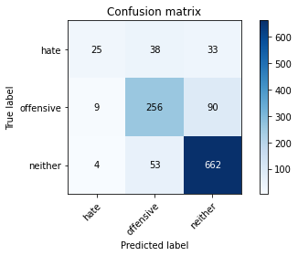

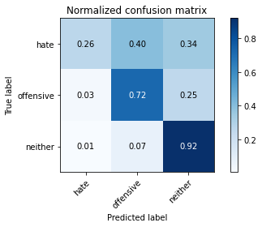

precision recall f1-score support

hate 0.66 0.26 0.37 96

offensive 0.74 0.72 0.73 355

neither 0.84 0.92 0.88 719

accuracy 0.81 1170

macro avg 0.75 0.63 0.66 1170

weighted avg 0.80 0.81 0.79 1170

average eval_loss: 0.4731443443540799, accuracy: 0.805982905982906

training 2 epoch...

69.10010528564453 seconds used......

2 training finished! average train loss: 0.8968752990675788

total clf loss: 85.20841261744499 total adv loss: 62.33020384795964

evaluating...

Confusion matrix, without normalization

[[ 46 33 17]

[ 9 290 56]

[ 8 82 629]]

Normalized confusion matrix

[[0.47916667 0.34375 0.17708333]

[0.02535211 0.81690141 0.15774648]

[0.01112656 0.11404729 0.87482615]]

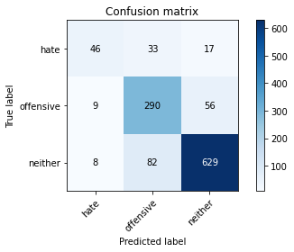

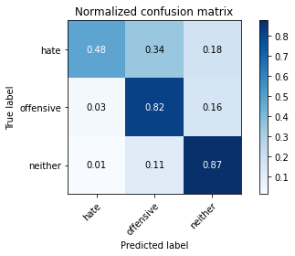

precision recall f1-score support

hate 0.73 0.48 0.58 96

offensive 0.72 0.82 0.76 355

neither 0.90 0.87 0.89 719

accuracy 0.82 1170

macro avg 0.78 0.72 0.74 1170

weighted avg 0.83 0.82 0.82 1170

average eval_loss: 0.45790689577490595, accuracy: 0.8247863247863247

training 3 epoch...

69.25404667854309 seconds used......

3 training finished! average train loss: 0.44351266213875806

total clf loss: 44.48782956972718 total adv loss: 29.647066831355914

evaluating...

Confusion matrix, without normalization

[[ 54 28 14]

[ 27 265 63]

[ 19 65 635]]

Normalized confusion matrix

[[0.5625 0.29166667 0.14583333]

[0.07605634 0.74647887 0.17746479]

[0.02642559 0.09040334 0.88317107]]

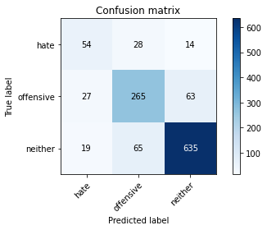

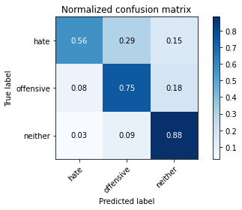

precision recall f1-score support

hate 0.54 0.56 0.55 96

offensive 0.74 0.75 0.74 355

neither 0.89 0.88 0.89 719

accuracy 0.82 1170

macro avg 0.72 0.73 0.73 1170

weighted avg 0.82 0.82 0.82 1170

average eval_loss: 0.5561167091383772, accuracy: 0.8153846153846154

training 4 epoch...

69.23813557624817 seconds used......

4 training finished! average train loss: 0.3078799144102213

total clf loss: 30.405379228759557 total adv loss: 20.819260236254195

evaluating...

Confusion matrix, without normalization

[[ 42 36 18]

[ 16 280 59]

[ 11 62 646]]

Normalized confusion matrix

[[0.4375 0.375 0.1875 ]

[0.04507042 0.78873239 0.16619718]

[0.01529903 0.08623088 0.8984701 ]]

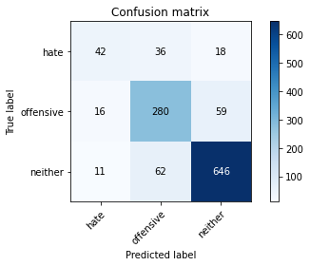

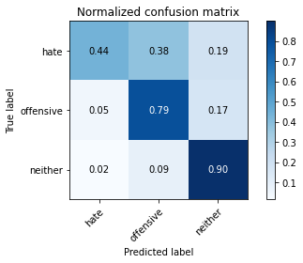

precision recall f1-score support

hate 0.61 0.44 0.51 96

offensive 0.74 0.79 0.76 355

neither 0.89 0.90 0.90 719

accuracy 0.83 1170

macro avg 0.75 0.71 0.72 1170

weighted avg 0.82 0.83 0.82 1170

average eval_loss: 0.5694369077287867, accuracy: 0.8273504273504273

training 5 epoch...

69.1767144203186 seconds used......

5 training finished! average train loss: 0.13809096141376048

total clf loss: 15.43703046767041 total adv loss: 8.438127294000878

evaluating...

Confusion matrix, without normalization

[[ 54 24 18]

[ 27 266 62]

[ 17 60 642]]

Normalized confusion matrix

[[0.5625 0.25 0.1875 ]

[0.07605634 0.74929577 0.17464789]

[0.02364395 0.08344924 0.89290682]]

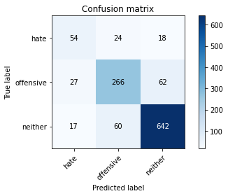

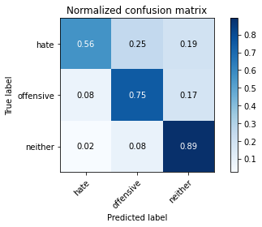

precision recall f1-score support

hate 0.55 0.56 0.56 96

offensive 0.76 0.75 0.75 355

neither 0.89 0.89 0.89 719

accuracy 0.82 1170

macro avg 0.73 0.73 0.73 1170

weighted avg 0.82 0.82 0.82 1170

average eval_loss: 0.6893107665355428, accuracy: 0.8222222222222222

training 6 epoch...

69.20391798019409 seconds used......

6 training finished! average train loss: 0.11172327457660507

total clf loss: 11.949351773713715 total adv loss: 7.096947179263225

evaluating...

Confusion matrix, without normalization

[[ 45 27 24]

[ 17 279 59]

[ 11 55 653]]

Normalized confusion matrix

[[0.46875 0.28125 0.25 ]

[0.04788732 0.78591549 0.16619718]

[0.01529903 0.07649513 0.90820584]]

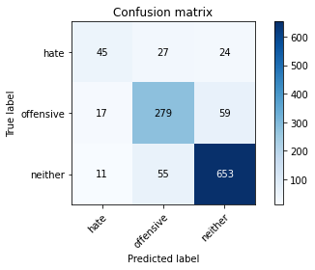

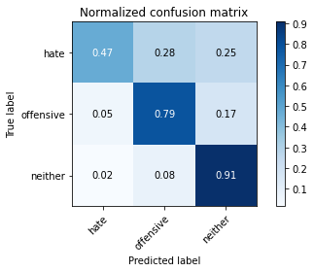

precision recall f1-score support

hate 0.62 0.47 0.53 96

offensive 0.77 0.79 0.78 355

neither 0.89 0.91 0.90 719

accuracy 0.84 1170

macro avg 0.76 0.72 0.74 1170

weighted avg 0.83 0.84 0.83 1170

average eval_loss: 0.7123727745818511, accuracy: 0.8350427350427351

training 7 epoch...

69.16839170455933 seconds used......

7 training finished! average train loss: 0.08562033152870405

total clf loss: 8.316107694990933 total adv loss: 5.859524937448441

evaluating...

Confusion matrix, without normalization

[[ 27 44 25]

[ 7 293 55]

[ 5 67 647]]

Normalized confusion matrix

[[0.28125 0.45833333 0.26041667]

[0.01971831 0.82535211 0.15492958]

[0.0069541 0.09318498 0.89986092]]

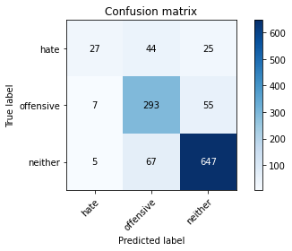

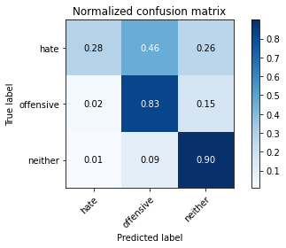

precision recall f1-score support

hate 0.69 0.28 0.40 96

offensive 0.73 0.83 0.77 355

neither 0.89 0.90 0.89 719

accuracy 0.83 1170

macro avg 0.77 0.67 0.69 1170

weighted avg 0.82 0.83 0.82 1170

average eval_loss: 0.7843379759687489, accuracy: 0.8264957264957264

training 8 epoch...

69.28827691078186 seconds used......

8 training finished! average train loss: 0.09716034854033914

total clf loss: 9.304755899240263 total adv loss: 6.715382839198355

evaluating...

Confusion matrix, without normalization

[[ 43 39 14]

[ 10 301 44]

[ 13 107 599]]

Normalized confusion matrix

[[0.44791667 0.40625 0.14583333]

[0.02816901 0.84788732 0.12394366]

[0.01808067 0.1488178 0.83310153]]

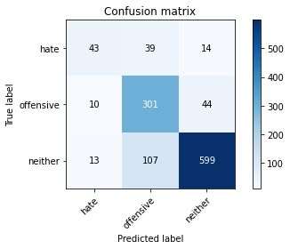

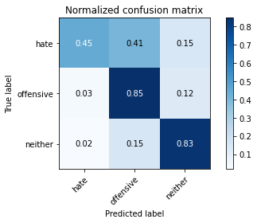

precision recall f1-score support

hate 0.65 0.45 0.53 96

offensive 0.67 0.85 0.75 355

neither 0.91 0.83 0.87 719

accuracy 0.81 1170

macro avg 0.75 0.71 0.72 1170

weighted avg 0.82 0.81 0.81 1170

average eval_loss: 0.8232188342391686, accuracy: 0.805982905982906

training 9 epoch...

69.33674001693726 seconds used......

9 training finished! average train loss: 0.04355342464290687

total clf loss: 4.173455915268278 total adv loss: 3.009022760427797

evaluating...

Confusion matrix, without normalization

[[ 43 26 27]

[ 16 251 88]

[ 5 31 683]]

Normalized confusion matrix

[[0.44791667 0.27083333 0.28125 ]

[0.04507042 0.70704225 0.24788732]

[0.0069541 0.04311544 0.94993046]]

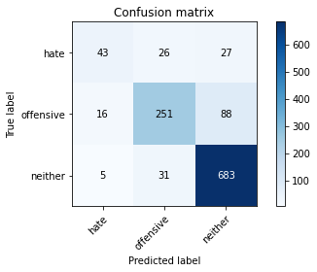

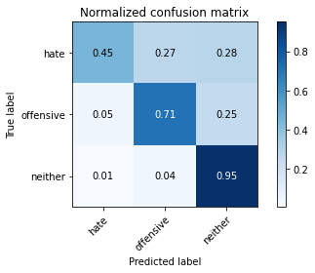

precision recall f1-score support

hate 0.67 0.45 0.54 96

offensive 0.81 0.71 0.76 355

neither 0.86 0.95 0.90 719

accuracy 0.84 1170

macro avg 0.78 0.70 0.73 1170

weighted avg 0.83 0.84 0.83 1170

average eval_loss: 0.8249699281937032, accuracy: 0.8350427350427351

training 10 epoch...

69.34668493270874 seconds used......

10 training finished! average train loss: 0.0694618976687909

total clf loss: 6.054231520014582 total adv loss: 5.099926312712341

evaluating...

Confusion matrix, without normalization

[[ 58 21 17]

[ 31 255 69]

[ 17 51 651]]

Normalized confusion matrix

[[0.60416667 0.21875 0.17708333]

[0.08732394 0.71830986 0.1943662 ]

[0.02364395 0.07093185 0.9054242 ]]

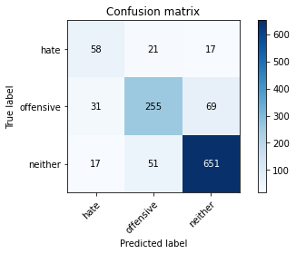

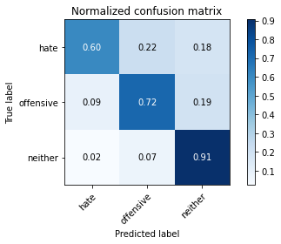

precision recall f1-score support

hate 0.55 0.60 0.57 96

offensive 0.78 0.72 0.75 355

neither 0.88 0.91 0.89 719

accuracy 0.82 1170

macro avg 0.74 0.74 0.74 1170

weighted avg 0.82 0.82 0.82 1170

average eval_loss: 0.827864172837847, accuracy: 0.8239316239316239

training 11 epoch...

69.27503848075867 seconds used......

11 training finished! average train loss: 0.05531514925995651

total clf loss: 4.954606731495005 total adv loss: 3.994569132446486

evaluating...

Confusion matrix, without normalization

[[ 43 41 12]

[ 14 292 49]

[ 12 92 615]]

Normalized confusion matrix

[[0.44791667 0.42708333 0.125 ]

[0.03943662 0.82253521 0.13802817]

[0.01668985 0.12795549 0.85535466]]

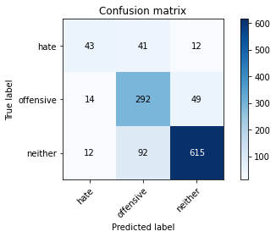

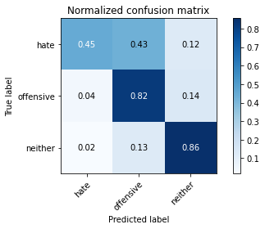

precision recall f1-score support

hate 0.62 0.45 0.52 96

offensive 0.69 0.82 0.75 355

neither 0.91 0.86 0.88 719

accuracy 0.81 1170

macro avg 0.74 0.71 0.72 1170

weighted avg 0.82 0.81 0.81 1170

average eval_loss: 0.9007732858723503, accuracy: 0.811965811965812

training 12 epoch...

69.25934147834778 seconds used......

12 training finished! average train loss: 0.06465965482574473

total clf loss: 6.133110508817481 total adv loss: 4.498624396517698

evaluating...

Confusion matrix, without normalization

[[ 47 38 11]

[ 14 295 46]

[ 15 95 609]]

Normalized confusion matrix

[[0.48958333 0.39583333 0.11458333]

[0.03943662 0.83098592 0.12957746]

[0.02086231 0.13212796 0.84700974]]

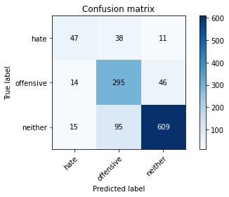

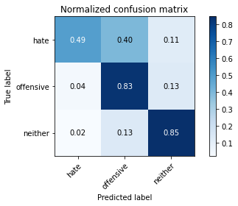

precision recall f1-score support

hate 0.62 0.49 0.55 96

offensive 0.69 0.83 0.75 355

neither 0.91 0.85 0.88 719

accuracy 0.81 1170

macro avg 0.74 0.72 0.73 1170

weighted avg 0.82 0.81 0.81 1170

average eval_loss: 0.9128136511702659, accuracy: 0.8128205128205128

training 13 epoch...

69.30107569694519 seconds used......

13 training finished! average train loss: 0.037078718142136216

total clf loss: 3.0991526906000217 total adv loss: 2.788633704191625

evaluating...

Confusion matrix, without normalization

[[ 58 28 10]

[ 30 273 52]

[ 22 92 605]]

Normalized confusion matrix

[[0.60416667 0.29166667 0.10416667]

[0.08450704 0.76901408 0.14647887]

[0.03059805 0.12795549 0.84144645]]

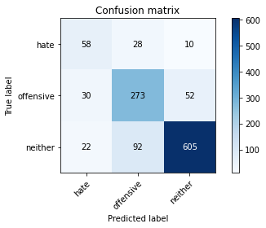

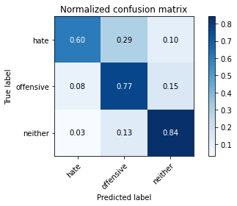

precision recall f1-score support

hate 0.53 0.60 0.56 96

offensive 0.69 0.77 0.73 355

neither 0.91 0.84 0.87 719

accuracy 0.80 1170

macro avg 0.71 0.74 0.72 1170

weighted avg 0.81 0.80 0.80 1170

average eval_loss: 1.0070161384222556, accuracy: 0.8

training 14 epoch...

69.22189974784851 seconds used......

14 training finished! average train loss: 0.025598105348763056

total clf loss: 2.2206651447704644 total adv loss: 1.8846457558304337

evaluating...

Confusion matrix, without normalization

[[ 63 17 16]

[ 21 246 88]

[ 13 37 669]]

Normalized confusion matrix

[[0.65625 0.17708333 0.16666667]

[0.05915493 0.69295775 0.24788732]

[0.01808067 0.05146036 0.93045897]]

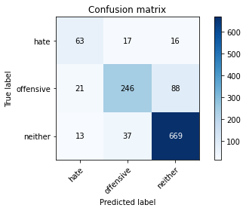

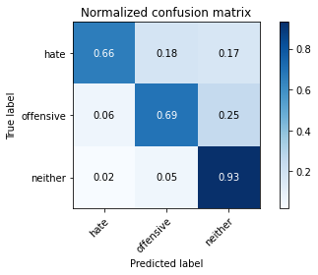

precision recall f1-score support

hate 0.65 0.66 0.65 96

offensive 0.82 0.69 0.75 355

neither 0.87 0.93 0.90 719

accuracy 0.84 1170

macro avg 0.78 0.76 0.77 1170

weighted avg 0.83 0.84 0.83 1170

average eval_loss: 0.9753641420787879, accuracy: 0.8358974358974359

training 15 epoch...

69.22583842277527 seconds used......

15 training finished! average train loss: 0.03334146182875036

total clf loss: 2.8089451652485877 total adv loss: 2.496478483391371

evaluating...

Confusion matrix, without normalization

[[ 17 54 25]

[ 2 268 85]

[ 0 43 676]]

Normalized confusion matrix

[[0.17708333 0.5625 0.26041667]

[0.0056338 0.75492958 0.23943662]

[0. 0.05980529 0.94019471]]

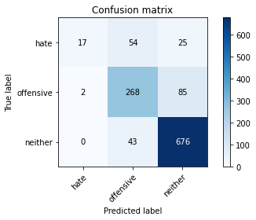

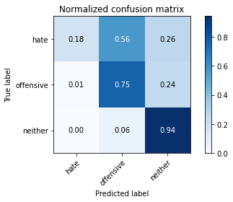

precision recall f1-score support

hate 0.89 0.18 0.30 96

offensive 0.73 0.75 0.74 355

neither 0.86 0.94 0.90 719

accuracy 0.82 1170

macro avg 0.83 0.62 0.65 1170

weighted avg 0.82 0.82 0.80 1170

average eval_loss: 1.1763316962588777, accuracy: 0.8213675213675213

training 16 epoch...

68.9152410030365 seconds used......

16 training finished! average train loss: 0.06787463759327592

total clf loss: 6.087484033938381 total adv loss: 4.897590684827833

evaluating...

Confusion matrix, without normalization

[[ 55 25 16]

[ 26 266 63]

[ 19 74 626]]

Normalized confusion matrix

[[0.57291667 0.26041667 0.16666667]

[0.07323944 0.74929577 0.17746479]

[0.02642559 0.10292072 0.87065369]]

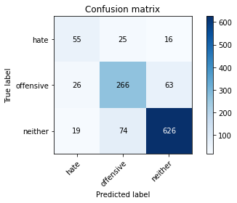

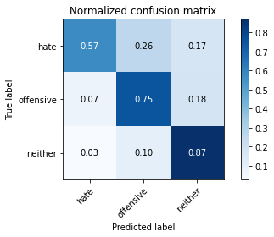

precision recall f1-score support

hate 0.55 0.57 0.56 96

offensive 0.73 0.75 0.74 355

neither 0.89 0.87 0.88 719

accuracy 0.81 1170

macro avg 0.72 0.73 0.73 1170

weighted avg 0.81 0.81 0.81 1170

average eval_loss: 0.9076070550245122, accuracy: 0.8094017094017094

training 17 epoch...

68.84384775161743 seconds used......

17 training finished! average train loss: 0.03291234647062643

total clf loss: 3.439473667887796 total adv loss: 2.1310077019988114

evaluating...

Confusion matrix, without normalization

[[ 68 14 14]

[ 46 238 71]

[ 31 30 658]]

Normalized confusion matrix

[[0.70833333 0.14583333 0.14583333]

[0.12957746 0.67042254 0.2 ]

[0.04311544 0.04172462 0.91515994]]

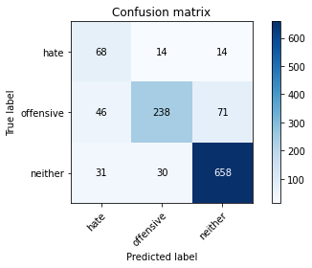

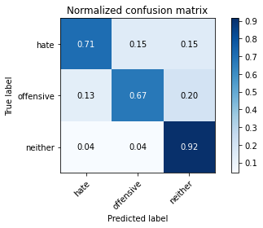

precision recall f1-score support

hate 0.47 0.71 0.56 96

offensive 0.84 0.67 0.75 355

neither 0.89 0.92 0.90 719

accuracy 0.82 1170

macro avg 0.73 0.76 0.74 1170

weighted avg 0.84 0.82 0.83 1170

average eval_loss: 0.9570936604927814, accuracy: 0.8239316239316239

training 18 epoch...

68.82424426078796 seconds used......

18 training finished! average train loss: 0.051018122759681

total clf loss: 4.408944520386285 total adv loss: 3.764648078517439

evaluating...

Confusion matrix, without normalization

[[ 50 31 15]

[ 22 273 60]

[ 20 61 638]]

Normalized confusion matrix

[[0.52083333 0.32291667 0.15625 ]

[0.06197183 0.76901408 0.16901408]

[0.02781641 0.08484006 0.88734353]]

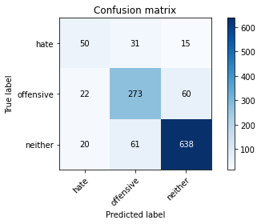

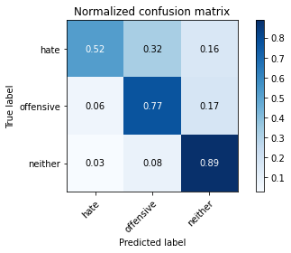

precision recall f1-score support

hate 0.54 0.52 0.53 96

offensive 0.75 0.77 0.76 355

neither 0.89 0.89 0.89 719

accuracy 0.82 1170

macro avg 0.73 0.73 0.73 1170

weighted avg 0.82 0.82 0.82 1170

average eval_loss: 0.8993243886033563, accuracy: 0.8213675213675213

training 19 epoch...

68.95784187316895 seconds used......

19 training finished! average train loss: 0.036370413836546225

total clf loss: 3.1292231784318574 total adv loss: 2.6907268329780436

evaluating...

Confusion matrix, without normalization

[[ 61 17 18]

[ 33 250 72]

[ 12 54 653]]

Normalized confusion matrix

[[0.63541667 0.17708333 0.1875 ]

[0.09295775 0.70422535 0.2028169 ]

[0.01668985 0.07510431 0.90820584]]

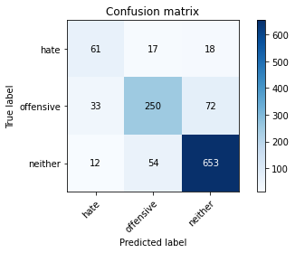

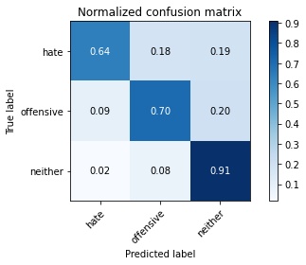

precision recall f1-score support

hate 0.58 0.64 0.60 96

offensive 0.78 0.70 0.74 355

neither 0.88 0.91 0.89 719

accuracy 0.82 1170

macro avg 0.74 0.75 0.75 1170

weighted avg 0.82 0.82 0.82 1170

average eval_loss: 0.8480555779789969, accuracy: 0.8239316239316239

training 20 epoch...

69.10371565818787 seconds used......

20 training finished! average train loss: 0.06576694608234421

total clf loss: 5.714854640398698 total adv loss: 4.837305325209172

evaluating...

Confusion matrix, without normalization

[[ 46 30 20]

[ 25 273 57]

[ 21 63 635]]

Normalized confusion matrix

[[0.47916667 0.3125 0.20833333]

[0.07042254 0.76901408 0.16056338]

[0.02920723 0.0876217 0.88317107]]

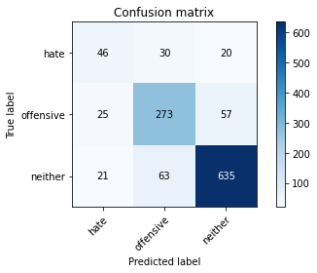

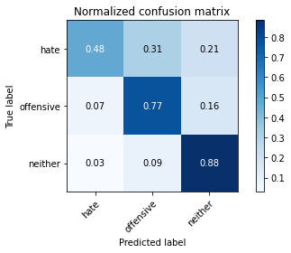

precision recall f1-score support

hate 0.50 0.48 0.49 96

offensive 0.75 0.77 0.76 355

neither 0.89 0.88 0.89 719

accuracy 0.82 1170

macro avg 0.71 0.71 0.71 1170

weighted avg 0.82 0.82 0.82 1170

average eval_loss: 0.8246088662516262, accuracy: 0.8153846153846154

2 run......

training 1 epoch...

69.18427681922913 seconds used......

1 training finished! average train loss: 1.514238229674152

total clf loss: 145.61846987903118 total adv loss: 104.35663804411888

evaluating...

Confusion matrix, without normalization

[[ 8 54 34]

[ 2 242 111]

[ 1 29 689]]

Normalized confusion matrix

[[0.08333333 0.5625 0.35416667]

[0.0056338 0.68169014 0.31267606]

[0.00139082 0.0403338 0.95827538]]

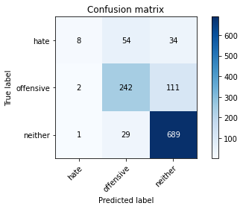

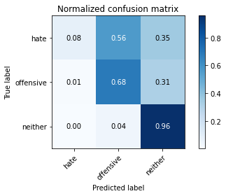

precision recall f1-score support

hate 0.73 0.08 0.15 96

offensive 0.74 0.68 0.71 355

neither 0.83 0.96 0.89 719

accuracy 0.80 1170

macro avg 0.77 0.57 0.58 1170

weighted avg 0.79 0.80 0.77 1170

average eval_loss: 0.5048484884328761, accuracy: 0.8025641025641026

training 2 epoch...

68.98945808410645 seconds used......

2 training finished! average train loss: 0.8781626938372595

total clf loss: 84.66921774297953 total adv loss: 60.41042652539909

evaluating...

Confusion matrix, without normalization

[[ 43 31 22]

[ 11 255 89]

[ 6 43 670]]

Normalized confusion matrix

[[0.44791667 0.32291667 0.22916667]

[0.03098592 0.71830986 0.25070423]

[0.00834492 0.05980529 0.93184979]]

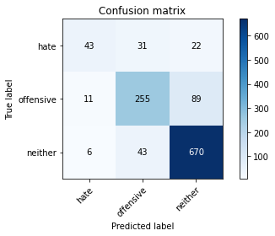

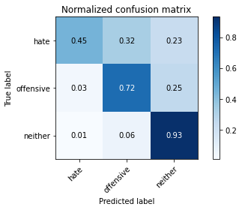

precision recall f1-score support

hate 0.72 0.45 0.55 96

offensive 0.78 0.72 0.75 355

neither 0.86 0.93 0.89 719

accuracy 0.83 1170

macro avg 0.78 0.70 0.73 1170

weighted avg 0.82 0.83 0.82 1170

average eval_loss: 0.46490307644767276, accuracy: 0.8273504273504273

training 3 epoch...

69.23543238639832 seconds used......

3 training finished! average train loss: 0.43294496417172956

total clf loss: 43.97315573878586 total adv loss: 28.667982764542103

evaluating...

Confusion matrix, without normalization

[[ 43 30 23]

[ 19 265 71]

[ 14 50 655]]

Normalized confusion matrix

[[0.44791667 0.3125 0.23958333]

[0.05352113 0.74647887 0.2 ]

[0.01947149 0.06954103 0.91098748]]

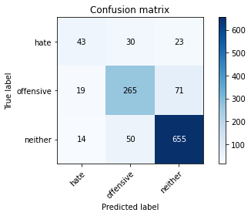

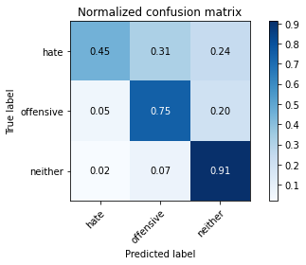

precision recall f1-score support

hate 0.57 0.45 0.50 96

offensive 0.77 0.75 0.76 355

neither 0.87 0.91 0.89 719

accuracy 0.82 1170

macro avg 0.74 0.70 0.72 1170

weighted avg 0.82 0.82 0.82 1170

average eval_loss: 0.5360403495319819, accuracy: 0.823076923076923

training 4 epoch...

69.15604329109192 seconds used......

4 training finished! average train loss: 0.24777703872348508

total clf loss: 25.514217666350305 total adv loss: 16.232804636121728

evaluating...

Confusion matrix, without normalization

[[ 58 30 8]

[ 37 273 45]

[ 52 78 589]]

Normalized confusion matrix

[[0.60416667 0.3125 0.08333333]

[0.10422535 0.76901408 0.12676056]

[0.07232267 0.10848401 0.81919332]]

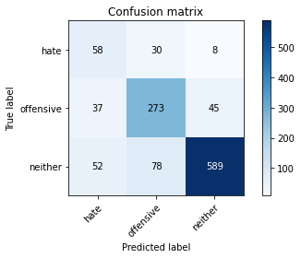

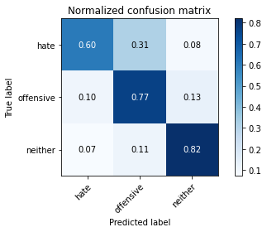

precision recall f1-score support

hate 0.39 0.60 0.48 96

offensive 0.72 0.77 0.74 355

neither 0.92 0.82 0.87 719

accuracy 0.79 1170

macro avg 0.68 0.73 0.69 1170

weighted avg 0.81 0.79 0.80 1170

average eval_loss: 0.7209380803850748, accuracy: 0.7863247863247863

training 5 epoch...

69.11717867851257 seconds used......

5 training finished! average train loss: 0.19036737577114096

total clf loss: 19.20584551501088 total adv loss: 12.67006015725201

evaluating...

Confusion matrix, without normalization

[[ 36 35 25]

[ 12 261 82]

[ 8 39 672]]

Normalized confusion matrix

[[0.375 0.36458333 0.26041667]

[0.03380282 0.73521127 0.23098592]

[0.01112656 0.054242 0.93463143]]

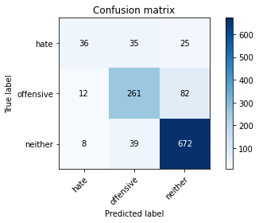

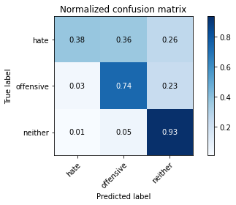

precision recall f1-score support

hate 0.64 0.38 0.47 96

offensive 0.78 0.74 0.76 355

neither 0.86 0.93 0.90 719

accuracy 0.83 1170

macro avg 0.76 0.68 0.71 1170

weighted avg 0.82 0.83 0.82 1170

average eval_loss: 0.6551589324312695, accuracy: 0.8282051282051283

training 6 epoch...

69.21579003334045 seconds used......

6 training finished! average train loss: 0.10761569210817704

total clf loss: 11.20280921983067 total adv loss: 6.989631416150587

evaluating...

Confusion matrix, without normalization

[[ 52 26 18]

[ 20 277 58]

[ 21 64 634]]

Normalized confusion matrix

[[0.54166667 0.27083333 0.1875 ]

[0.05633803 0.78028169 0.16338028]

[0.02920723 0.08901252 0.88178025]]

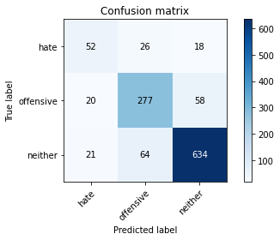

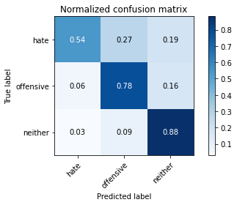

precision recall f1-score support

hate 0.56 0.54 0.55 96

offensive 0.75 0.78 0.77 355

neither 0.89 0.88 0.89 719

accuracy 0.82 1170

macro avg 0.74 0.73 0.73 1170

weighted avg 0.82 0.82 0.82 1170

average eval_loss: 0.7579534073060347, accuracy: 0.823076923076923

training 7 epoch...

69.09708380699158 seconds used......

7 training finished! average train loss: 0.08493637774064022

total clf loss: 8.597050980373751 total adv loss: 5.6390306952016545

evaluating...

Confusion matrix, without normalization

[[ 31 41 24]

[ 13 262 80]

[ 5 45 669]]

Normalized confusion matrix

[[0.32291667 0.42708333 0.25 ]

[0.03661972 0.73802817 0.22535211]

[0.0069541 0.06258693 0.93045897]]

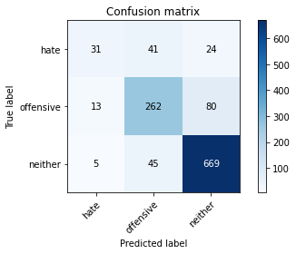

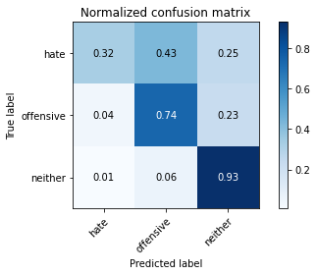

precision recall f1-score support

hate 0.63 0.32 0.43 96

offensive 0.75 0.74 0.75 355

neither 0.87 0.93 0.90 719

accuracy 0.82 1170

macro avg 0.75 0.66 0.69 1170

weighted avg 0.81 0.82 0.81 1170

average eval_loss: 0.753575661436702, accuracy: 0.8222222222222222

training 8 epoch...

69.195472240448 seconds used......

8 training finished! average train loss: 0.0879046896026812

total clf loss: 8.475490801443812 total adv loss: 6.047103269147556

evaluating...

Confusion matrix, without normalization

[[ 48 30 18]

[ 22 272 61]

[ 18 67 634]]

Normalized confusion matrix

[[0.5 0.3125 0.1875 ]

[0.06197183 0.76619718 0.17183099]

[0.02503477 0.09318498 0.88178025]]

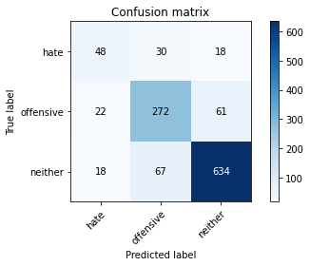

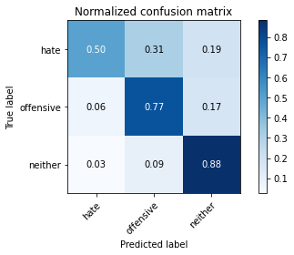

precision recall f1-score support

hate 0.55 0.50 0.52 96

offensive 0.74 0.77 0.75 355

neither 0.89 0.88 0.89 719

accuracy 0.82 1170

macro avg 0.72 0.72 0.72 1170

weighted avg 0.81 0.82 0.81 1170

average eval_loss: 0.8449346856293032, accuracy: 0.8153846153846154

training 9 epoch...

69.19285702705383 seconds used......

9 training finished! average train loss: 0.0854568676570327

total clf loss: 7.610948500834638 total adv loss: 6.192979322280735

evaluating...

Confusion matrix, without normalization

[[ 60 17 19]

[ 40 234 81]

[ 21 31 667]]

Normalized confusion matrix

[[0.625 0.17708333 0.19791667]

[0.11267606 0.65915493 0.22816901]

[0.02920723 0.04311544 0.92767733]]

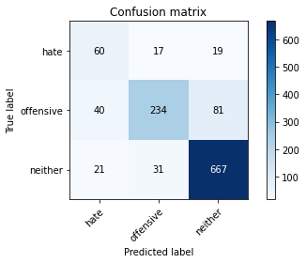

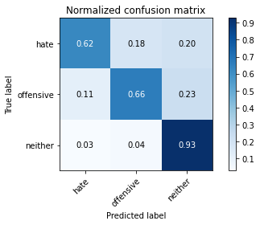

precision recall f1-score support

hate 0.50 0.62 0.55 96

offensive 0.83 0.66 0.73 355

neither 0.87 0.93 0.90 719

accuracy 0.82 1170

macro avg 0.73 0.74 0.73 1170

weighted avg 0.83 0.82 0.82 1170

average eval_loss: 0.8523133542325537, accuracy: 0.8213675213675213

training 10 epoch...

69.23874688148499 seconds used......

10 training finished! average train loss: 0.04753649986421681

total clf loss: 4.77488924030331 total adv loss: 3.1743259056675015

evaluating...

Confusion matrix, without normalization

[[ 48 27 21]

[ 26 249 80]

[ 14 38 667]]

Normalized confusion matrix

[[0.5 0.28125 0.21875 ]

[0.07323944 0.70140845 0.22535211]

[0.01947149 0.05285118 0.92767733]]

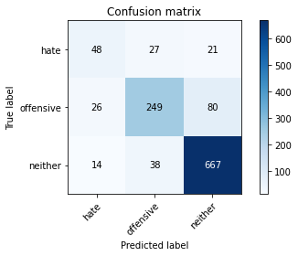

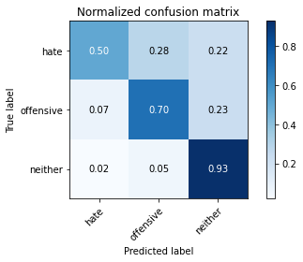

precision recall f1-score support

hate 0.55 0.50 0.52 96

offensive 0.79 0.70 0.74 355

neither 0.87 0.93 0.90 719

accuracy 0.82 1170

macro avg 0.74 0.71 0.72 1170

weighted avg 0.82 0.82 0.82 1170

average eval_loss: 0.8759565412045173, accuracy: 0.8239316239316239

training 11 epoch...

69.25846433639526 seconds used......

11 training finished! average train loss: 0.027781592340407092

total clf loss: 2.498698104885989 total adv loss: 2.001097229313018

evaluating...

Confusion matrix, without normalization

[[ 45 33 18]

[ 18 271 66]

[ 13 59 647]]

Normalized confusion matrix

[[0.46875 0.34375 0.1875 ]

[0.05070423 0.76338028 0.18591549]

[0.01808067 0.08205841 0.89986092]]

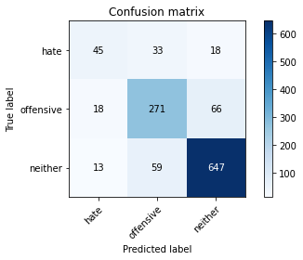

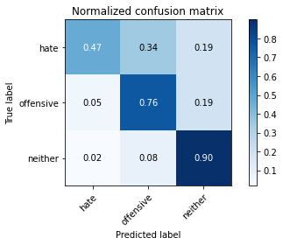

precision recall f1-score support

hate 0.59 0.47 0.52 96

offensive 0.75 0.76 0.75 355

neither 0.89 0.90 0.89 719

accuracy 0.82 1170

macro avg 0.74 0.71 0.72 1170

weighted avg 0.82 0.82 0.82 1170

average eval_loss: 0.8910171646561663, accuracy: 0.823076923076923

training 12 epoch...

69.26896905899048 seconds used......

12 training finished! average train loss: 0.030845801146568146

total clf loss: 2.969237504148623 total adv loss: 2.124339989683321

evaluating...

Confusion matrix, without normalization

[[ 42 36 18]

[ 18 269 68]

[ 12 61 646]]

Normalized confusion matrix

[[0.4375 0.375 0.1875 ]

[0.05070423 0.75774648 0.1915493 ]

[0.01668985 0.08484006 0.8984701 ]]

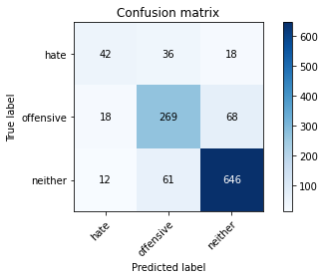

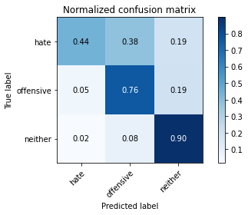

precision recall f1-score support

hate 0.58 0.44 0.50 96

offensive 0.73 0.76 0.75 355

neither 0.88 0.90 0.89 719

accuracy 0.82 1170

macro avg 0.73 0.70 0.71 1170

weighted avg 0.81 0.82 0.81 1170

average eval_loss: 0.8717857159386089, accuracy: 0.8179487179487179

training 13 epoch...

69.29142880439758 seconds used......

13 training finished! average train loss: 0.040441629247808066

total clf loss: 3.54549901514838 total adv loss: 2.9589210705585174

evaluating...

Confusion matrix, without normalization

[[ 72 18 6]

[ 52 247 56]

[ 70 53 596]]

Normalized confusion matrix

[[0.75 0.1875 0.0625 ]

[0.14647887 0.69577465 0.15774648]

[0.09735744 0.07371349 0.82892907]]

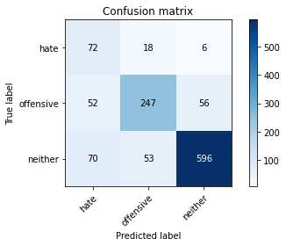

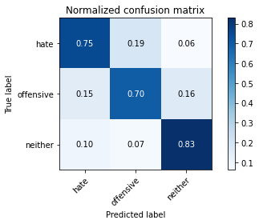

precision recall f1-score support

hate 0.37 0.75 0.50 96

offensive 0.78 0.70 0.73 355

neither 0.91 0.83 0.87 719

accuracy 0.78 1170

macro avg 0.68 0.76 0.70 1170

weighted avg 0.82 0.78 0.80 1170

average eval_loss: 1.0820187519667512, accuracy: 0.782051282051282

training 14 epoch...

69.30759191513062 seconds used......

14 training finished! average train loss: 0.06449256595420655

total clf loss: 5.743865025448031 total adv loss: 4.673697737899602

evaluating...

Confusion matrix, without normalization

[[ 46 20 30]

[ 24 211 120]

[ 4 17 698]]

Normalized confusion matrix

[[0.47916667 0.20833333 0.3125 ]

[0.06760563 0.5943662 0.33802817]

[0.00556328 0.02364395 0.97079277]]

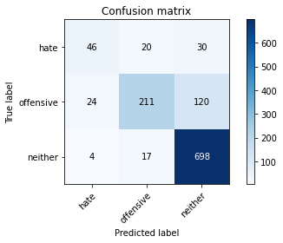

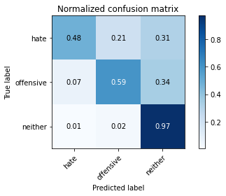

precision recall f1-score support

hate 0.62 0.48 0.54 96

offensive 0.85 0.59 0.70 355

neither 0.82 0.97 0.89 719

accuracy 0.82 1170

macro avg 0.77 0.68 0.71 1170

weighted avg 0.81 0.82 0.80 1170

average eval_loss: 1.1104409544298552, accuracy: 0.8162393162393162

training 15 epoch...

69.12195897102356 seconds used......

15 training finished! average train loss: 0.09738353605401547

total clf loss: 7.770771920273546 total adv loss: 7.508487703644278

evaluating...

Confusion matrix, without normalization

[[ 39 42 15]

[ 13 294 48]

[ 8 104 607]]

Normalized confusion matrix

[[0.40625 0.4375 0.15625 ]

[0.03661972 0.82816901 0.13521127]

[0.01112656 0.14464534 0.84422809]]

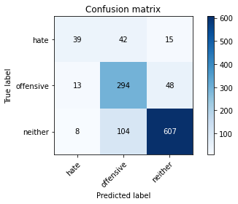

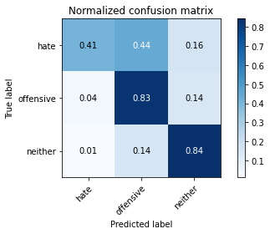

precision recall f1-score support

hate 0.65 0.41 0.50 96

offensive 0.67 0.83 0.74 355

neither 0.91 0.84 0.87 719

accuracy 0.80 1170

macro avg 0.74 0.69 0.70 1170

weighted avg 0.81 0.80 0.80 1170

average eval_loss: 0.9463094888981116, accuracy: 0.8034188034188035

training 16 epoch...

69.05124974250793 seconds used......

16 training finished! average train loss: 0.04717451526215509

total clf loss: 4.343464987381594 total adv loss: 3.3476857623479646

evaluating...

Confusion matrix, without normalization

[[ 54 24 18]

[ 19 266 70]

[ 19 59 641]]

Normalized confusion matrix

[[0.5625 0.25 0.1875 ]

[0.05352113 0.74929577 0.1971831 ]

[0.02642559 0.08205841 0.89151599]]

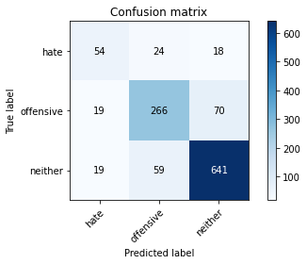

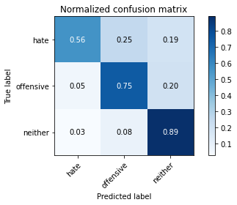

precision recall f1-score support

hate 0.59 0.56 0.57 96

offensive 0.76 0.75 0.76 355

neither 0.88 0.89 0.89 719

accuracy 0.82 1170

macro avg 0.74 0.73 0.74 1170

weighted avg 0.82 0.82 0.82 1170

average eval_loss: 0.8605865013580454, accuracy: 0.8213675213675213

training 17 epoch...

69.1358072757721 seconds used......

17 training finished! average train loss: 0.03672910333908577

total clf loss: 2.943151203697198 total adv loss: 2.8257295249077288

evaluating...

Confusion matrix, without normalization

[[ 58 21 17]

[ 31 261 63]

[ 19 63 637]]

Normalized confusion matrix

[[0.60416667 0.21875 0.17708333]

[0.08732394 0.73521127 0.17746479]

[0.02642559 0.0876217 0.88595271]]

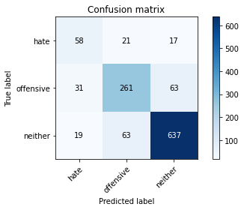

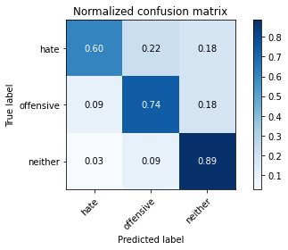

precision recall f1-score support

hate 0.54 0.60 0.57 96

offensive 0.76 0.74 0.75 355

neither 0.89 0.89 0.89 719

accuracy 0.82 1170

macro avg 0.73 0.74 0.73 1170

weighted avg 0.82 0.82 0.82 1170

average eval_loss: 1.0143173233747989, accuracy: 0.8170940170940171

training 18 epoch...

69.09871792793274 seconds used......

18 training finished! average train loss: 0.009525098390782721

total clf loss: 0.8906559363458655 total adv loss: 0.6691085380352888

evaluating...

Confusion matrix, without normalization

[[ 50 28 18]

[ 27 266 62]

[ 20 73 626]]

Normalized confusion matrix

[[0.52083333 0.29166667 0.1875 ]

[0.07605634 0.74929577 0.17464789]

[0.02781641 0.1015299 0.87065369]]

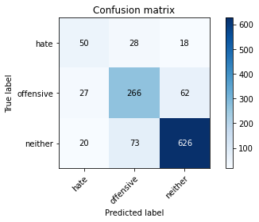

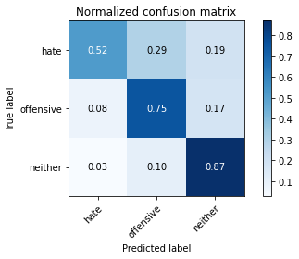

precision recall f1-score support

hate 0.52 0.52 0.52 96

offensive 0.72 0.75 0.74 355

neither 0.89 0.87 0.88 719

accuracy 0.81 1170

macro avg 0.71 0.71 0.71 1170

weighted avg 0.81 0.81 0.81 1170

average eval_loss: 1.0669478037773426, accuracy: 0.8051282051282052

training 19 epoch...

69.03968667984009 seconds used......

19 training finished! average train loss: 0.05007352496598202

total clf loss: 3.74850158670597 total adv loss: 3.9843516341252325

evaluating...

Confusion matrix, without normalization

[[ 51 35 10]

[ 21 296 38]

[ 36 124 559]]

Normalized confusion matrix

[[0.53125 0.36458333 0.10416667]

[0.05915493 0.83380282 0.10704225]

[0.05006954 0.17246175 0.77746871]]

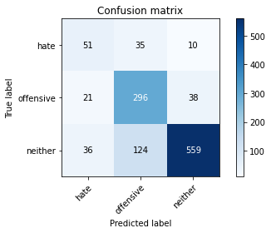

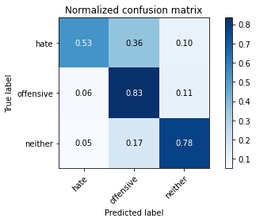

precision recall f1-score support

hate 0.47 0.53 0.50 96

offensive 0.65 0.83 0.73 355

neither 0.92 0.78 0.84 719

accuracy 0.77 1170

macro avg 0.68 0.71 0.69 1170

weighted avg 0.80 0.77 0.78 1170

average eval_loss: 1.1757733632131653, accuracy: 0.7743589743589744

training 20 epoch...

69.1417350769043 seconds used......

20 training finished! average train loss: 0.02820450899746661

total clf loss: 2.4434502454387257 total adv loss: 2.078202425753261

evaluating...

Confusion matrix, without normalization

[[ 64 13 19]

[ 44 235 76]

[ 28 44 647]]

Normalized confusion matrix

[[0.66666667 0.13541667 0.19791667]

[0.12394366 0.66197183 0.21408451]

[0.03894298 0.06119611 0.89986092]]

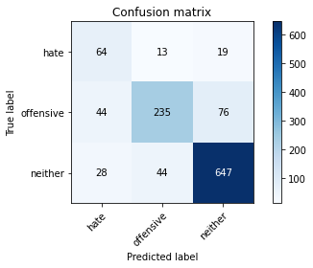

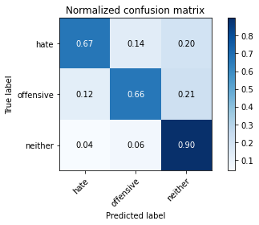

precision recall f1-score support

hate 0.47 0.67 0.55 96

offensive 0.80 0.66 0.73 355

neither 0.87 0.90 0.89 719

accuracy 0.81 1170

macro avg 0.72 0.74 0.72 1170

weighted avg 0.82 0.81 0.81 1170

average eval_loss: 1.0555312838089668, accuracy: 0.8085470085470086

3 run......

training 1 epoch...

69.0751006603241 seconds used......

1 training finished! average train loss: 1.511990441216363

total clf loss: 145.19579149782658 total adv loss: 104.30498644709587

evaluating...

Confusion matrix, without normalization

[[ 4 67 25]

[ 1 286 68]

[ 0 83 636]]

Normalized confusion matrix

[[0.04166667 0.69791667 0.26041667]

[0.0028169 0.8056338 0.1915493 ]

[0. 0.11543811 0.88456189]]

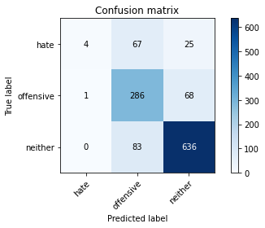

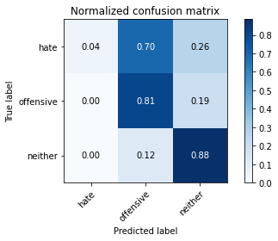

precision recall f1-score support

hate 0.80 0.04 0.08 96

offensive 0.66 0.81 0.72 355

neither 0.87 0.88 0.88 719

accuracy 0.79 1170

macro avg 0.78 0.58 0.56 1170

weighted avg 0.80 0.79 0.77 1170

average eval_loss: 0.5021847006628068, accuracy: 0.7914529914529914

training 2 epoch...

69.07049679756165 seconds used......

2 training finished! average train loss: 0.9096720719821433

total clf loss: 86.14756332337856 total adv loss: 63.357850428670645

evaluating...

Confusion matrix, without normalization

[[ 5 54 37]

[ 0 252 103]

[ 0 34 685]]

Normalized confusion matrix

[[0.05208333 0.5625 0.38541667]

[0. 0.70985915 0.29014085]

[0. 0.0472879 0.9527121 ]]

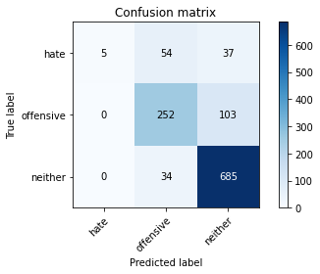

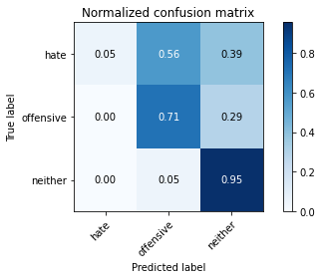

precision recall f1-score support

hate 1.00 0.05 0.10 96

offensive 0.74 0.71 0.73 355

neither 0.83 0.95 0.89 719

accuracy 0.81 1170

macro avg 0.86 0.57 0.57 1170

weighted avg 0.82 0.81 0.77 1170

average eval_loss: 0.5128627927752875, accuracy: 0.8051282051282052

training 3 epoch...

69.11631441116333 seconds used......

3 training finished! average train loss: 0.4848629601108722

total clf loss: 49.09016056731343 total adv loss: 32.18388595804572

evaluating...

Confusion matrix, without normalization

[[ 35 26 35]

[ 4 235 116]

[ 2 30 687]]

Normalized confusion matrix

[[0.36458333 0.27083333 0.36458333]

[0.01126761 0.66197183 0.32676056]

[0.00278164 0.04172462 0.95549374]]

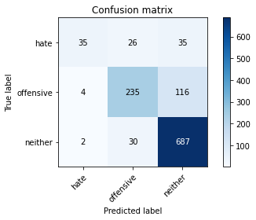

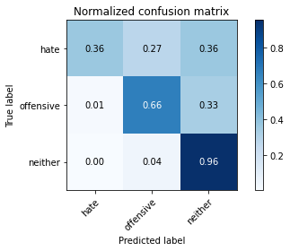

precision recall f1-score support

hate 0.85 0.36 0.51 96

offensive 0.81 0.66 0.73 355

neither 0.82 0.96 0.88 719

accuracy 0.82 1170

macro avg 0.83 0.66 0.71 1170

weighted avg 0.82 0.82 0.80 1170

average eval_loss: 0.6027843198123373, accuracy: 0.8179487179487179

training 4 epoch...

69.06794500350952 seconds used......

4 training finished! average train loss: 0.2478672716464115

total clf loss: 26.980340051464736 total adv loss: 15.510300736757927

evaluating...

Confusion matrix, without normalization

[[ 48 20 28]

[ 29 212 114]

[ 9 22 688]]

Normalized confusion matrix

[[0.5 0.20833333 0.29166667]

[0.08169014 0.5971831 0.32112676]

[0.01251739 0.03059805 0.95688456]]

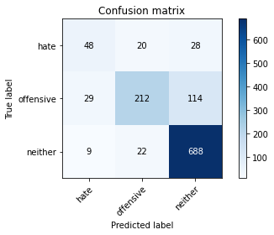

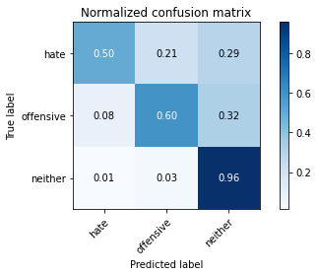

precision recall f1-score support

hate 0.56 0.50 0.53 96

offensive 0.83 0.60 0.70 355

neither 0.83 0.96 0.89 719

accuracy 0.81 1170

macro avg 0.74 0.68 0.70 1170

weighted avg 0.81 0.81 0.80 1170

average eval_loss: 0.7488375818514723, accuracy: 0.8102564102564103

training 5 epoch...

69.08534026145935 seconds used......

5 training finished! average train loss: 0.17501102076867261

total clf loss: 17.672420487040654 total adv loss: 11.640079076714756

evaluating...

Confusion matrix, without normalization

[[ 42 35 19]

[ 14 257 84]

[ 12 52 655]]

Normalized confusion matrix

[[0.4375 0.36458333 0.19791667]

[0.03943662 0.72394366 0.23661972]

[0.01668985 0.07232267 0.91098748]]

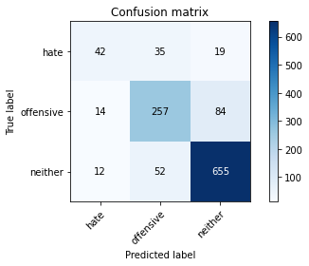

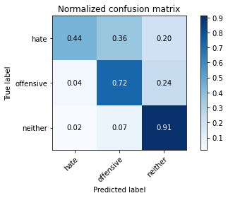

precision recall f1-score support

hate 0.62 0.44 0.51 96

offensive 0.75 0.72 0.74 355

neither 0.86 0.91 0.89 719

accuracy 0.82 1170

macro avg 0.74 0.69 0.71 1170

weighted avg 0.81 0.82 0.81 1170

average eval_loss: 0.7414501839459448, accuracy: 0.8153846153846154

training 6 epoch...

69.11926460266113 seconds used......

6 training finished! average train loss: 0.098855140643855

total clf loss: 10.322850890923291 total adv loss: 6.404625946928718

evaluating...

Confusion matrix, without normalization

[[ 53 31 12]

[ 22 275 58]

[ 24 67 628]]

Normalized confusion matrix

[[0.55208333 0.32291667 0.125 ]

[0.06197183 0.77464789 0.16338028]

[0.03337969 0.09318498 0.87343533]]

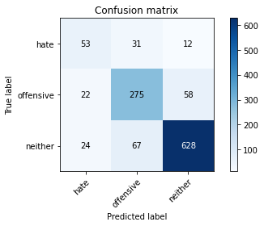

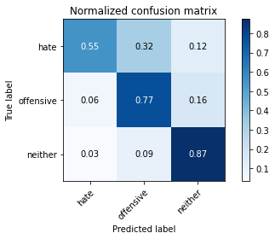

precision recall f1-score support

hate 0.54 0.55 0.54 96

offensive 0.74 0.77 0.76 355

neither 0.90 0.87 0.89 719

accuracy 0.82 1170

macro avg 0.72 0.73 0.73 1170

weighted avg 0.82 0.82 0.82 1170

average eval_loss: 0.736979964631215, accuracy: 0.8170940170940171

training 7 epoch...

69.06712365150452 seconds used......

7 training finished! average train loss: 0.11232420111584485

total clf loss: 10.264941435540095 total adv loss: 8.009460769560974

evaluating...

Confusion matrix, without normalization

[[ 48 29 19]

[ 20 263 72]

[ 15 61 643]]

Normalized confusion matrix

[[0.5 0.30208333 0.19791667]

[0.05633803 0.74084507 0.2028169 ]

[0.02086231 0.08484006 0.89429764]]

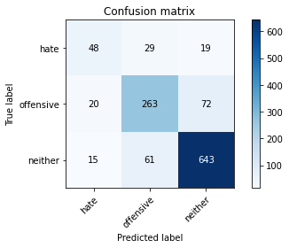

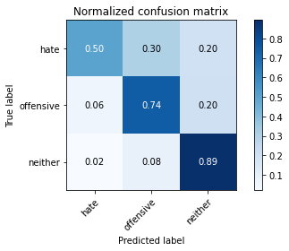

precision recall f1-score support

hate 0.58 0.50 0.54 96

offensive 0.75 0.74 0.74 355

neither 0.88 0.89 0.89 719

accuracy 0.82 1170

macro avg 0.73 0.71 0.72 1170

weighted avg 0.81 0.82 0.81 1170

average eval_loss: 0.7826783190149877, accuracy: 0.8153846153846154

training 8 epoch...

69.29418468475342 seconds used......

8 training finished! average train loss: 0.07410676087228915

total clf loss: 7.11690697009908 total adv loss: 5.112037485461769

evaluating...

Confusion matrix, without normalization

[[ 51 28 17]

[ 23 284 48]

[ 23 75 621]]

Normalized confusion matrix

[[0.53125 0.29166667 0.17708333]

[0.06478873 0.8 0.13521127]

[0.03198887 0.10431154 0.86369958]]

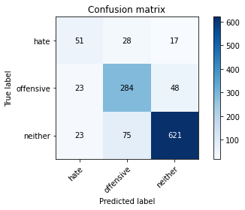

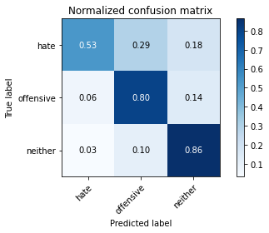

precision recall f1-score support

hate 0.53 0.53 0.53 96

offensive 0.73 0.80 0.77 355

neither 0.91 0.86 0.88 719

accuracy 0.82 1170

macro avg 0.72 0.73 0.73 1170

weighted avg 0.82 0.82 0.82 1170

average eval_loss: 0.8645841707238706, accuracy: 0.8170940170940171

training 9 epoch...

69.05642056465149 seconds used......

9 training finished! average train loss: 0.06695826688127664

total clf loss: 5.864768735948019 total adv loss: 4.901732853788417

evaluating...

Confusion matrix, without normalization

[[ 47 27 22]

[ 21 257 77]

[ 16 44 659]]

Normalized confusion matrix

[[0.48958333 0.28125 0.22916667]

[0.05915493 0.72394366 0.21690141]

[0.02225313 0.06119611 0.91655076]]

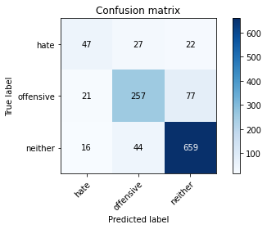

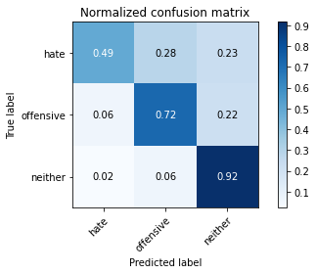

precision recall f1-score support

hate 0.56 0.49 0.52 96

offensive 0.78 0.72 0.75 355

neither 0.87 0.92 0.89 719

accuracy 0.82 1170

macro avg 0.74 0.71 0.72 1170

weighted avg 0.82 0.82 0.82 1170

average eval_loss: 0.8257011233165986, accuracy: 0.823076923076923

training 10 epoch...

68.8820960521698 seconds used......

10 training finished! average train loss: 0.030900835446888007

total clf loss: 2.9915053868317045 total adv loss: 2.1196450539873695

evaluating...

Confusion matrix, without normalization

[[ 39 39 18]

[ 9 294 52]

[ 13 105 601]]

Normalized confusion matrix

[[0.40625 0.40625 0.1875 ]

[0.02535211 0.82816901 0.14647887]

[0.01808067 0.14603616 0.83588317]]

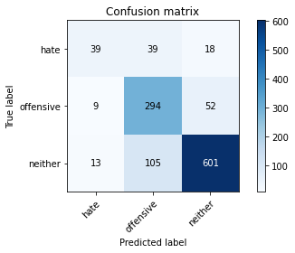

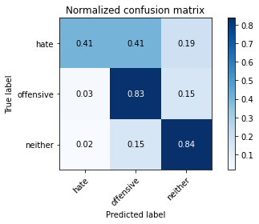

precision recall f1-score support

hate 0.64 0.41 0.50 96

offensive 0.67 0.83 0.74 355

neither 0.90 0.84 0.86 719

accuracy 0.80 1170

macro avg 0.74 0.69 0.70 1170

weighted avg 0.81 0.80 0.80 1170

average eval_loss: 0.9809747031589938, accuracy: 0.7982905982905983

training 11 epoch...

68.87088322639465 seconds used......

11 training finished! average train loss: 0.05389094961446195

total clf loss: 5.133663224885822 total adv loss: 3.7384094746091705

evaluating...

Confusion matrix, without normalization

[[ 61 20 15]

[ 42 255 58]

[ 29 56 634]]

Normalized confusion matrix

[[0.63541667 0.20833333 0.15625 ]

[0.11830986 0.71830986 0.16338028]

[0.0403338 0.07788595 0.88178025]]

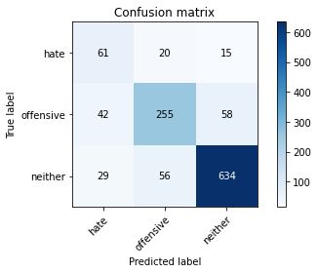

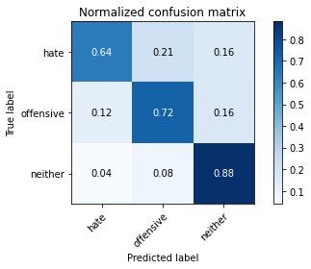

precision recall f1-score support

hate 0.46 0.64 0.54 96

offensive 0.77 0.72 0.74 355

neither 0.90 0.88 0.89 719

accuracy 0.81 1170

macro avg 0.71 0.75 0.72 1170

weighted avg 0.82 0.81 0.82 1170

average eval_loss: 0.9135049800704218, accuracy: 0.811965811965812

training 12 epoch...

68.92926955223083 seconds used......

12 training finished! average train loss: 0.061493597592875905

total clf loss: 5.412502196471905 total adv loss: 4.488499831921217

evaluating...

Confusion matrix, without normalization

[[ 47 28 21]

[ 26 255 74]

[ 19 50 650]]

Normalized confusion matrix

[[0.48958333 0.29166667 0.21875 ]

[0.07323944 0.71830986 0.2084507 ]

[0.02642559 0.06954103 0.90403338]]

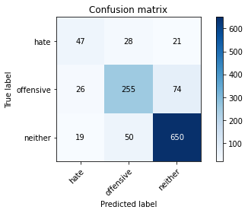

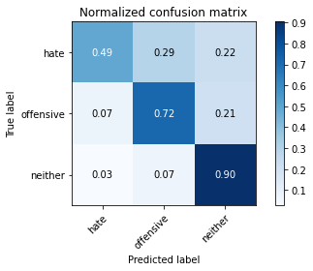

precision recall f1-score support

hate 0.51 0.49 0.50 96

offensive 0.77 0.72 0.74 355

neither 0.87 0.90 0.89 719

accuracy 0.81 1170

macro avg 0.72 0.70 0.71 1170

weighted avg 0.81 0.81 0.81 1170

average eval_loss: 0.8617231710774477, accuracy: 0.8136752136752137

training 13 epoch...

68.94712543487549 seconds used......

13 training finished! average train loss: 0.04648097179224118

total clf loss: 4.549416490568547 total adv loss: 3.163565489126995

evaluating...

Confusion matrix, without normalization

[[ 45 35 16]

[ 18 284 53]

[ 20 82 617]]

Normalized confusion matrix

[[0.46875 0.36458333 0.16666667]

[0.05070423 0.8 0.14929577]

[0.02781641 0.11404729 0.8581363 ]]

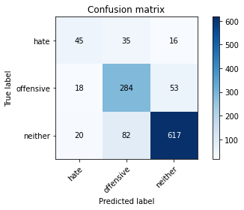

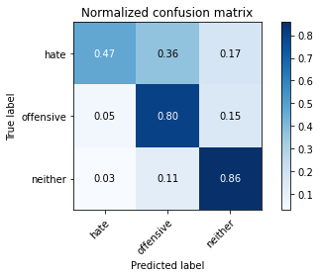

precision recall f1-score support

hate 0.54 0.47 0.50 96

offensive 0.71 0.80 0.75 355

neither 0.90 0.86 0.88 719

accuracy 0.81 1170

macro avg 0.72 0.71 0.71 1170

weighted avg 0.81 0.81 0.81 1170

average eval_loss: 0.9534912443467243, accuracy: 0.8085470085470086

training 14 epoch...

69.23451519012451 seconds used......

14 training finished! average train loss: 0.04821073696716006

total clf loss: 4.694322742434451 total adv loss: 3.2934948872170935

evaluating...

Confusion matrix, without normalization

[[ 53 31 12]

[ 28 282 45]

[ 33 80 606]]

Normalized confusion matrix

[[0.55208333 0.32291667 0.125 ]

[0.07887324 0.7943662 0.12676056]

[0.04589708 0.11126565 0.84283727]]

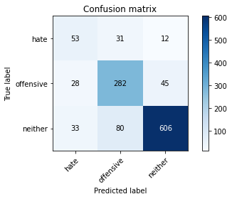

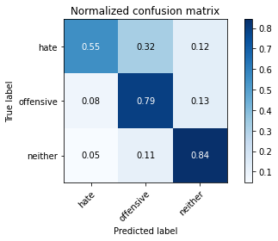

precision recall f1-score support

hate 0.46 0.55 0.50 96

offensive 0.72 0.79 0.75 355

neither 0.91 0.84 0.88 719

accuracy 0.80 1170

macro avg 0.70 0.73 0.71 1170

weighted avg 0.82 0.80 0.81 1170

average eval_loss: 0.9376563292817545, accuracy: 0.8042735042735043

training 15 epoch...

69.34099340438843 seconds used......

15 training finished! average train loss: 0.06652379202674856

total clf loss: 5.758622668188764 total adv loss: 4.903972281957067

evaluating...

Confusion matrix, without normalization

[[ 42 35 19]

[ 14 286 55]

[ 11 90 618]]

Normalized confusion matrix

[[0.4375 0.36458333 0.19791667]

[0.03943662 0.8056338 0.15492958]

[0.01529903 0.12517385 0.85952712]]

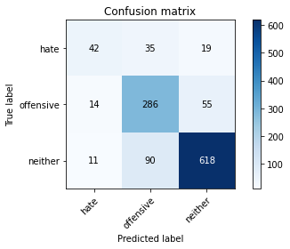

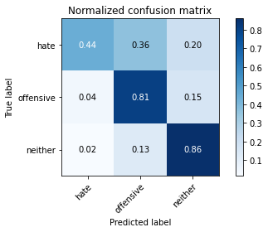

precision recall f1-score support

hate 0.63 0.44 0.52 96

offensive 0.70 0.81 0.75 355

neither 0.89 0.86 0.88 719

accuracy 0.81 1170

macro avg 0.74 0.70 0.71 1170

weighted avg 0.81 0.81 0.81 1170

average eval_loss: 0.9936769491503552, accuracy: 0.8085470085470086

training 16 epoch...

69.15497374534607 seconds used......

16 training finished! average train loss: 0.02517792537233058

total clf loss: 2.233687040148652 total adv loss: 1.8289736941442243

evaluating...

Confusion matrix, without normalization

[[ 60 21 15]

[ 37 266 52]

[ 26 68 625]]

Normalized confusion matrix

[[0.625 0.21875 0.15625 ]

[0.10422535 0.74929577 0.14647887]

[0.03616134 0.0945758 0.86926287]]

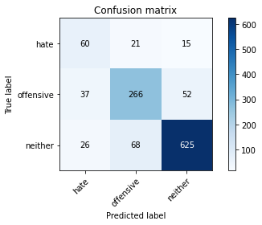

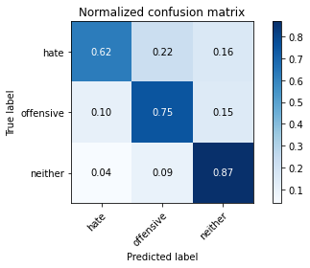

precision recall f1-score support

hate 0.49 0.62 0.55 96

offensive 0.75 0.75 0.75 355

neither 0.90 0.87 0.89 719

accuracy 0.81 1170

macro avg 0.71 0.75 0.73 1170

weighted avg 0.82 0.81 0.82 1170

average eval_loss: 1.036904413000507, accuracy: 0.8128205128205128

training 17 epoch...

69.08474946022034 seconds used......

17 training finished! average train loss: 0.03367601666832343

total clf loss: 2.6643414777790895 total adv loss: 2.6079231636026634

evaluating...

Confusion matrix, without normalization

[[ 53 26 17]

[ 31 274 50]

[ 23 82 614]]

Normalized confusion matrix

[[0.55208333 0.27083333 0.17708333]

[0.08732394 0.77183099 0.14084507]

[0.03198887 0.11404729 0.85396384]]

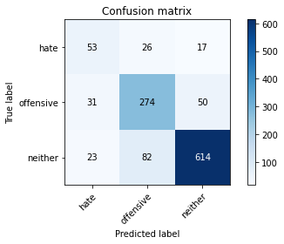

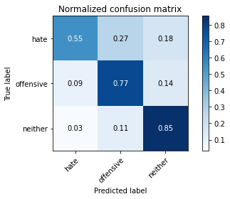

precision recall f1-score support

hate 0.50 0.55 0.52 96

offensive 0.72 0.77 0.74 355

neither 0.90 0.85 0.88 719

accuracy 0.80 1170

macro avg 0.70 0.73 0.71 1170

weighted avg 0.81 0.80 0.81 1170

average eval_loss: 1.004919788547618, accuracy: 0.8042735042735043

training 18 epoch...

69.28305339813232 seconds used......

18 training finished! average train loss: 0.023469147054315843

total clf loss: 1.9554155419464223 total adv loss: 1.7681824022943147

evaluating...

Confusion matrix, without normalization

[[ 47 24 25]

[ 27 239 89]

[ 8 36 675]]

Normalized confusion matrix

[[0.48958333 0.25 0.26041667]

[0.07605634 0.67323944 0.25070423]

[0.01112656 0.05006954 0.93880389]]

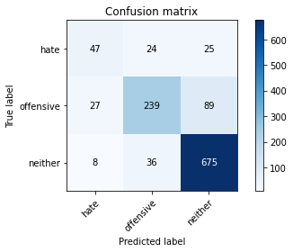

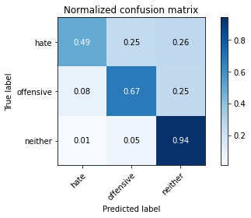

precision recall f1-score support

hate 0.57 0.49 0.53 96

offensive 0.80 0.67 0.73 355

neither 0.86 0.94 0.90 719

accuracy 0.82 1170

macro avg 0.74 0.70 0.72 1170

weighted avg 0.82 0.82 0.82 1170

average eval_loss: 1.0522635702548895, accuracy: 0.8213675213675213

training 19 epoch...

69.10964894294739 seconds used......

19 training finished! average train loss: 0.02524275253176128

total clf loss: 2.362110229594691 total adv loss: 1.7723469475669162

evaluating...

Confusion matrix, without normalization

[[ 64 8 24]

[ 61 183 111]

[ 16 20 683]]

Normalized confusion matrix

[[0.66666667 0.08333333 0.25 ]

[0.17183099 0.51549296 0.31267606]

[0.02225313 0.02781641 0.94993046]]

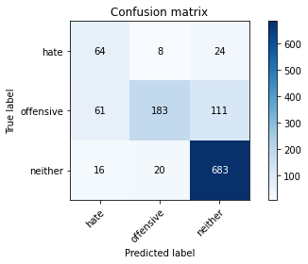

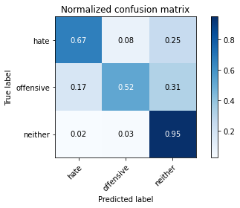

precision recall f1-score support

hate 0.45 0.67 0.54 96

offensive 0.87 0.52 0.65 355

neither 0.83 0.95 0.89 719

accuracy 0.79 1170

macro avg 0.72 0.71 0.69 1170

weighted avg 0.81 0.79 0.79 1170

average eval_loss: 1.1147545154316951, accuracy: 0.7948717948717948

training 20 epoch...

69.22624564170837 seconds used......

20 training finished! average train loss: 0.07207956985312039

total clf loss: 5.5473339154268615 total adv loss: 5.65964267927211

evaluating...

Confusion matrix, without normalization

[[ 48 32 16]

[ 27 269 59]

[ 13 72 634]]

Normalized confusion matrix

[[0.5 0.33333333 0.16666667]

[0.07605634 0.75774648 0.16619718]

[0.01808067 0.10013908 0.88178025]]

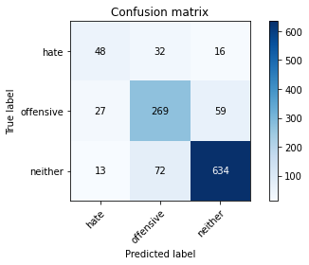

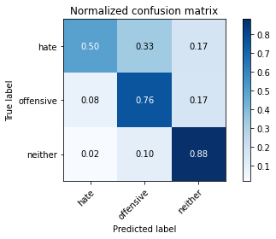

precision recall f1-score support

hate 0.55 0.50 0.52 96

offensive 0.72 0.76 0.74 355

neither 0.89 0.88 0.89 719

accuracy 0.81 1170

macro avg 0.72 0.71 0.72 1170

weighted avg 0.81 0.81 0.81 1170

average eval_loss: 0.8981108147950875, accuracy: 0.8128205128205128

4 run......

training 1 epoch...

69.12776064872742 seconds used......

1 training finished! average train loss: 1.5338404092014346

total clf loss: 145.6039350181818 total adv loss: 106.6573606878519

evaluating...

Confusion matrix, without normalization

[[ 28 46 22]

[ 12 259 84]

[ 3 65 651]]

Normalized confusion matrix

[[0.29166667 0.47916667 0.22916667]

[0.03380282 0.72957746 0.23661972]

[0.00417246 0.09040334 0.9054242 ]]

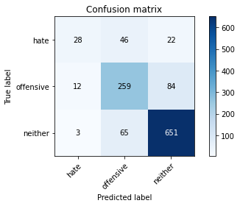

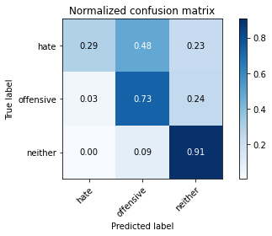

precision recall f1-score support

hate 0.65 0.29 0.40 96

offensive 0.70 0.73 0.71 355

neither 0.86 0.91 0.88 719

accuracy 0.80 1170

macro avg 0.74 0.64 0.67 1170

weighted avg 0.79 0.80 0.79 1170

average eval_loss: 0.47666861243167163, accuracy: 0.8017094017094017

training 2 epoch...

69.23113512992859 seconds used......

2 training finished! average train loss: 0.944750366684718

total clf loss: 89.14905439689755 total adv loss: 65.96126624569297

evaluating...

Confusion matrix, without normalization

[[ 52 30 14]

[ 25 283 47]

[ 20 90 609]]

Normalized confusion matrix

[[0.54166667 0.3125 0.14583333]

[0.07042254 0.7971831 0.13239437]

[0.02781641 0.12517385 0.84700974]]

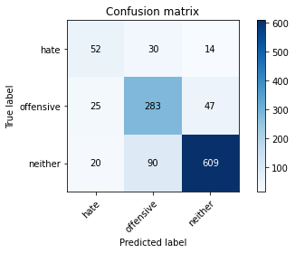

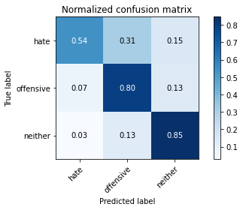

precision recall f1-score support

hate 0.54 0.54 0.54 96

offensive 0.70 0.80 0.75 355

neither 0.91 0.85 0.88 719

accuracy 0.81 1170

macro avg 0.72 0.73 0.72 1170

weighted avg 0.82 0.81 0.81 1170

average eval_loss: 0.4976067123776775, accuracy: 0.8068376068376069

training 3 epoch...

69.15830039978027 seconds used......

3 training finished! average train loss: 0.48491749769219983

total clf loss: 47.00391843635589 total adv loss: 33.23338795546442

evaluating...

Confusion matrix, without normalization

[[ 51 27 18]

[ 18 252 85]

[ 14 52 653]]

Normalized confusion matrix

[[0.53125 0.28125 0.1875 ]

[0.05070423 0.70985915 0.23943662]

[0.01947149 0.07232267 0.90820584]]

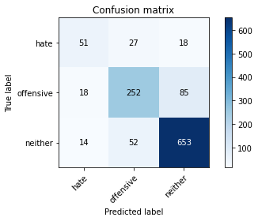

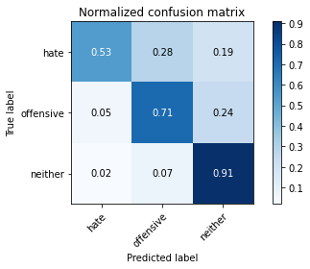

precision recall f1-score support

hate 0.61 0.53 0.57 96

offensive 0.76 0.71 0.73 355

neither 0.86 0.91 0.89 719

accuracy 0.82 1170

macro avg 0.75 0.72 0.73 1170

weighted avg 0.81 0.82 0.81 1170

average eval_loss: 0.5076760059948695, accuracy: 0.8170940170940171

training 4 epoch...

69.08259892463684 seconds used......

4 training finished! average train loss: 0.23372863326619706

total clf loss: 23.706006200052798 total adv loss: 15.493246998492396

evaluating...

Confusion matrix, without normalization

[[ 48 31 17]

[ 21 268 66]

[ 21 68 630]]

Normalized confusion matrix

[[0.5 0.32291667 0.17708333]

[0.05915493 0.75492958 0.18591549]

[0.02920723 0.0945758 0.87621697]]

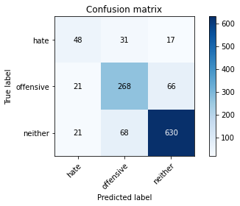

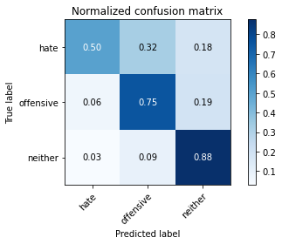

precision recall f1-score support

hate 0.53 0.50 0.52 96

offensive 0.73 0.75 0.74 355

neither 0.88 0.88 0.88 719

accuracy 0.81 1170

macro avg 0.72 0.71 0.71 1170

weighted avg 0.81 0.81 0.81 1170

average eval_loss: 0.6667916187069426, accuracy: 0.8085470085470086

training 5 epoch...

69.02305960655212 seconds used......

5 training finished! average train loss: 0.1439565797137399

total clf loss: 15.739853665349074 total adv loss: 8.972992928531312

evaluating...

Confusion matrix, without normalization

[[ 45 37 14]

[ 17 293 45]

[ 15 107 597]]

Normalized confusion matrix

[[0.46875 0.38541667 0.14583333]

[0.04788732 0.82535211 0.12676056]

[0.02086231 0.1488178 0.83031989]]

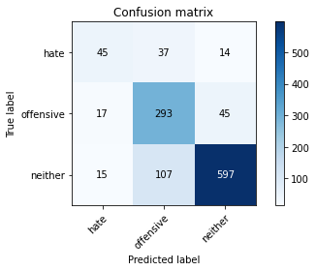

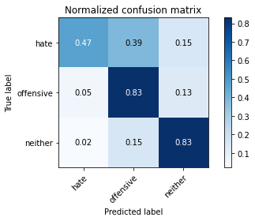

precision recall f1-score support

hate 0.58 0.47 0.52 96

offensive 0.67 0.83 0.74 355

neither 0.91 0.83 0.87 719

accuracy 0.80 1170

macro avg 0.72 0.71 0.71 1170

weighted avg 0.81 0.80 0.80 1170

average eval_loss: 0.8021839852839455, accuracy: 0.7991452991452992

training 6 epoch...

68.93988132476807 seconds used......

6 training finished! average train loss: 0.153522614935417

total clf loss: 14.199998656462412 total adv loss: 10.862146629053314

evaluating...

Confusion matrix, without normalization

[[ 56 26 14]

[ 19 267 69]

[ 22 57 640]]

Normalized confusion matrix

[[0.58333333 0.27083333 0.14583333]

[0.05352113 0.75211268 0.1943662 ]

[0.03059805 0.07927677 0.89012517]]

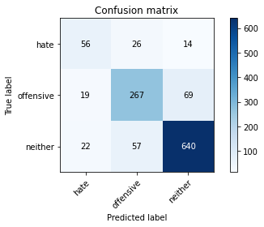

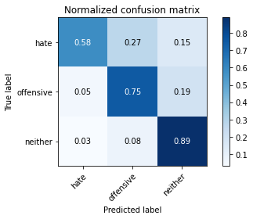

precision recall f1-score support

hate 0.58 0.58 0.58 96

offensive 0.76 0.75 0.76 355

neither 0.89 0.89 0.89 719

accuracy 0.82 1170

macro avg 0.74 0.74 0.74 1170

weighted avg 0.82 0.82 0.82 1170

average eval_loss: 0.7345949210368602, accuracy: 0.823076923076923

training 7 epoch...

68.78362321853638 seconds used......

7 training finished! average train loss: 0.08754683366298087

total clf loss: 8.000024069158826 total adv loss: 6.242967533013143

evaluating...

Confusion matrix, without normalization

[[ 37 33 26]

[ 8 251 96]

[ 2 42 675]]

Normalized confusion matrix

[[0.38541667 0.34375 0.27083333]

[0.02253521 0.70704225 0.27042254]

[0.00278164 0.05841446 0.93880389]]

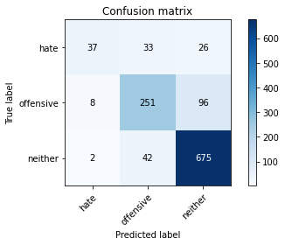

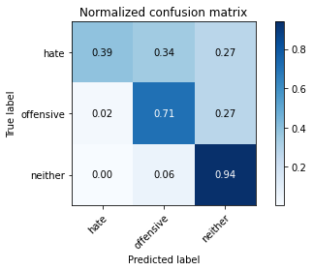

precision recall f1-score support

hate 0.79 0.39 0.52 96

offensive 0.77 0.71 0.74 355

neither 0.85 0.94 0.89 719

accuracy 0.82 1170

macro avg 0.80 0.68 0.72 1170

weighted avg 0.82 0.82 0.81 1170

average eval_loss: 0.9010062272210558, accuracy: 0.823076923076923

training 8 epoch...

68.88444995880127 seconds used......

8 training finished! average train loss: 0.07915480790608045

total clf loss: 7.2701762929791585 total adv loss: 5.626024364892146

evaluating...

Confusion matrix, without normalization

[[ 46 31 19]

[ 15 274 66]

[ 17 71 631]]

Normalized confusion matrix

[[0.47916667 0.32291667 0.19791667]

[0.04225352 0.77183099 0.18591549]

[0.02364395 0.09874826 0.87760779]]

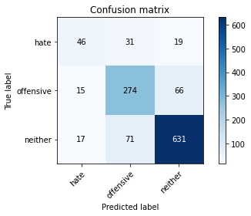

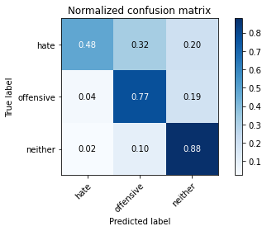

precision recall f1-score support

hate 0.59 0.48 0.53 96

offensive 0.73 0.77 0.75 355

neither 0.88 0.88 0.88 719

accuracy 0.81 1170

macro avg 0.73 0.71 0.72 1170

weighted avg 0.81 0.81 0.81 1170

average eval_loss: 0.7972097884630784, accuracy: 0.8128205128205128

training 9 epoch...

68.8300850391388 seconds used......

9 training finished! average train loss: 0.029990177797342643

total clf loss: 2.950487454261747 total adv loss: 2.0336070765265504

evaluating...

Confusion matrix, without normalization

[[ 57 23 16]

[ 21 265 69]

[ 17 58 644]]

Normalized confusion matrix

[[0.59375 0.23958333 0.16666667]

[0.05915493 0.74647887 0.1943662 ]

[0.02364395 0.08066759 0.89568846]]

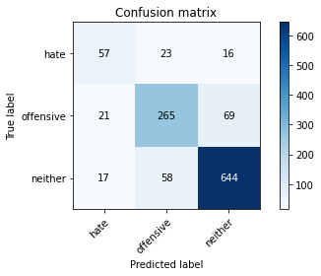

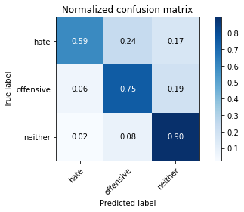

precision recall f1-score support

hate 0.60 0.59 0.60 96

offensive 0.77 0.75 0.76 355

neither 0.88 0.90 0.89 719

accuracy 0.83 1170

macro avg 0.75 0.75 0.75 1170

weighted avg 0.82 0.83 0.83 1170

average eval_loss: 0.9150465389075334, accuracy: 0.8256410256410256

training 10 epoch...

68.74419617652893 seconds used......

10 training finished! average train loss: 0.06275343593205256

total clf loss: 5.606770624144701 total adv loss: 4.53876667732311

evaluating...

Confusion matrix, without normalization

[[ 56 20 20]

[ 25 263 67]

[ 21 57 641]]

Normalized confusion matrix

[[0.58333333 0.20833333 0.20833333]

[0.07042254 0.74084507 0.18873239]

[0.02920723 0.07927677 0.89151599]]

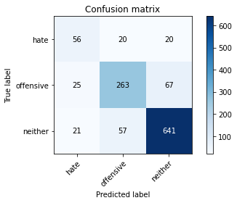

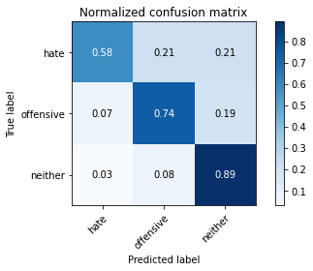

precision recall f1-score support

hate 0.55 0.58 0.57 96

offensive 0.77 0.74 0.76 355

neither 0.88 0.89 0.89 719

accuracy 0.82 1170

macro avg 0.73 0.74 0.74 1170

weighted avg 0.82 0.82 0.82 1170

average eval_loss: 0.902692399870691, accuracy: 0.8205128205128205

training 11 epoch...

68.82211065292358 seconds used......

11 training finished! average train loss: 0.06482730386505087

total clf loss: 6.340973766404204 total adv loss: 4.414307744935286

evaluating...

Confusion matrix, without normalization

[[ 57 14 25]

[ 33 225 97]

[ 13 36 670]]

Normalized confusion matrix

[[0.59375 0.14583333 0.26041667]

[0.09295775 0.63380282 0.27323944]

[0.01808067 0.05006954 0.93184979]]

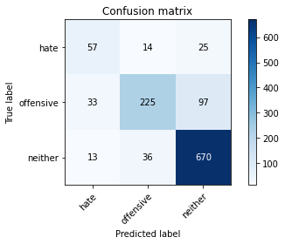

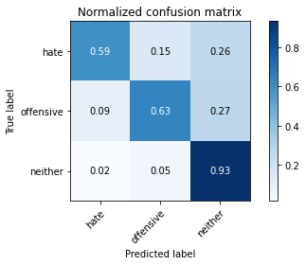

precision recall f1-score support

hate 0.55 0.59 0.57 96

offensive 0.82 0.63 0.71 355

neither 0.85 0.93 0.89 719

accuracy 0.81 1170

macro avg 0.74 0.72 0.72 1170

weighted avg 0.81 0.81 0.81 1170

average eval_loss: 0.9256624172725794, accuracy: 0.8136752136752137

training 12 epoch...

68.7710030078888 seconds used......

12 training finished! average train loss: 0.05825450958355238

total clf loss: 5.204070621897699 total adv loss: 4.213742272004538

evaluating...

Confusion matrix, without normalization

[[ 36 25 35]

[ 6 261 88]

[ 1 52 666]]

Normalized confusion matrix

[[0.375 0.26041667 0.36458333]

[0.01690141 0.73521127 0.24788732]

[0.00139082 0.07232267 0.92628651]]

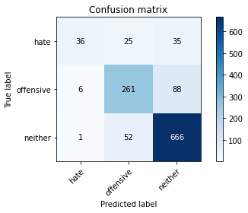

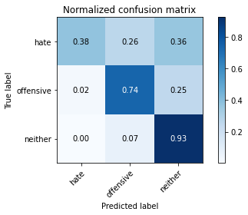

precision recall f1-score support

hate 0.84 0.38 0.52 96

offensive 0.77 0.74 0.75 355

neither 0.84 0.93 0.88 719

accuracy 0.82 1170

macro avg 0.82 0.68 0.72 1170

weighted avg 0.82 0.82 0.81 1170

average eval_loss: 1.013547401476683, accuracy: 0.823076923076923

training 13 epoch...

68.81751871109009 seconds used......

13 training finished! average train loss: 0.062021834683581155

total clf loss: 6.1133940749423346 total adv loss: 4.199857604500636

evaluating...

Confusion matrix, without normalization

[[ 55 17 24]

[ 30 234 91]

[ 16 35 668]]

Normalized confusion matrix

[[0.57291667 0.17708333 0.25 ]

[0.08450704 0.65915493 0.25633803]

[0.02225313 0.04867872 0.92906815]]

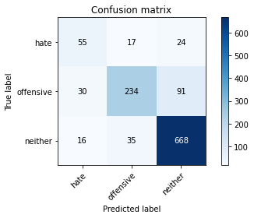

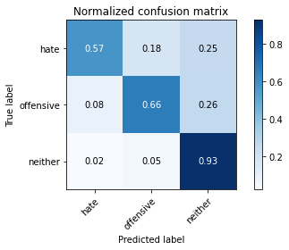

precision recall f1-score support

hate 0.54 0.57 0.56 96

offensive 0.82 0.66 0.73 355

neither 0.85 0.93 0.89 719

accuracy 0.82 1170

macro avg 0.74 0.72 0.73 1170

weighted avg 0.82 0.82 0.81 1170

average eval_loss: 0.9249354161803564, accuracy: 0.8179487179487179

training 14 epoch...

68.8656096458435 seconds used......

14 training finished! average train loss: 0.0430514605151953

total clf loss: 3.605332288556383 total adv loss: 3.2343547574882905

evaluating...

Confusion matrix, without normalization

[[ 36 33 27]

[ 13 274 68]

[ 5 50 664]]

Normalized confusion matrix

[[0.375 0.34375 0.28125 ]

[0.03661972 0.77183099 0.1915493 ]

[0.0069541 0.06954103 0.92350487]]

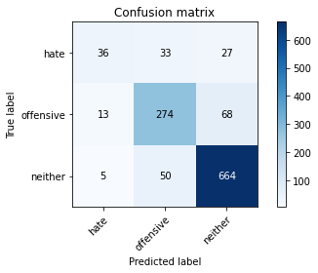

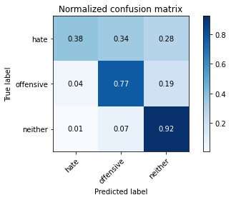

precision recall f1-score support

hate 0.67 0.38 0.48 96

offensive 0.77 0.77 0.77 355

neither 0.87 0.92 0.90 719

accuracy 0.83 1170

macro avg 0.77 0.69 0.72 1170

weighted avg 0.83 0.83 0.83 1170

average eval_loss: 0.9516282900196098, accuracy: 0.8324786324786325

training 15 epoch...

68.84426307678223 seconds used......

15 training finished! average train loss: 0.04305857318750997

total clf loss: 3.942700239131227 total adv loss: 3.0665029112337834

evaluating...

Confusion matrix, without normalization

[[ 56 26 14]

[ 23 260 72]

[ 20 52 647]]

Normalized confusion matrix

[[0.58333333 0.27083333 0.14583333]

[0.06478873 0.73239437 0.2028169 ]

[0.02781641 0.07232267 0.89986092]]

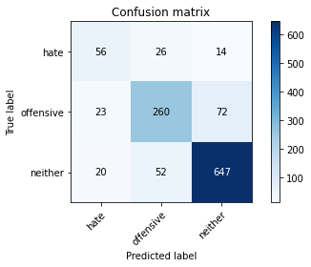

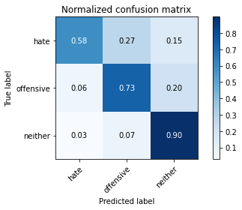

precision recall f1-score support

hate 0.57 0.58 0.57 96

offensive 0.77 0.73 0.75 355

neither 0.88 0.90 0.89 719

accuracy 0.82 1170

macro avg 0.74 0.74 0.74 1170

weighted avg 0.82 0.82 0.82 1170

average eval_loss: 0.9697089748618871, accuracy: 0.823076923076923

training 16 epoch...

68.79010534286499 seconds used......

16 training finished! average train loss: 0.037441305244731035

total clf loss: 3.5367595923307817 total adv loss: 2.612252925641542

evaluating...

Confusion matrix, without normalization

[[ 50 24 22]

[ 21 252 82]

[ 9 48 662]]

Normalized confusion matrix

[[0.52083333 0.25 0.22916667]

[0.05915493 0.70985915 0.23098592]

[0.01251739 0.06675939 0.92072323]]

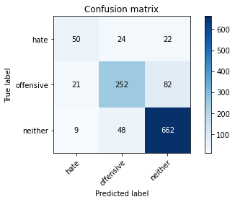

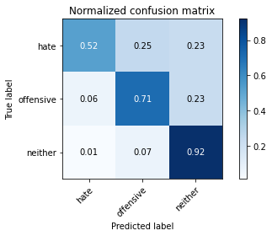

precision recall f1-score support

hate 0.62 0.52 0.57 96

offensive 0.78 0.71 0.74 355

neither 0.86 0.92 0.89 719

accuracy 0.82 1170

macro avg 0.76 0.72 0.73 1170

weighted avg 0.82 0.82 0.82 1170

average eval_loss: 0.9514640663053457, accuracy: 0.8239316239316239

training 17 epoch...

68.75038528442383 seconds used......

17 training finished! average train loss: 0.009038230028861893

total clf loss: 0.9029719249228947 total adv loss: 0.6059869452888051

evaluating...

Confusion matrix, without normalization

[[ 56 28 12]

[ 26 290 39]

[ 26 99 594]]

Normalized confusion matrix

[[0.58333333 0.29166667 0.125 ]

[0.07323944 0.81690141 0.10985915]

[0.03616134 0.13769124 0.82614743]]

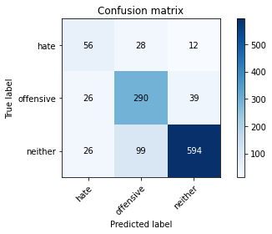

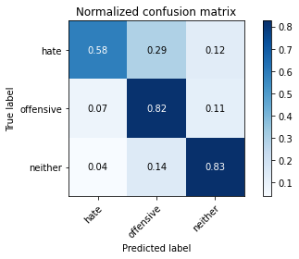

precision recall f1-score support

hate 0.52 0.58 0.55 96

offensive 0.70 0.82 0.75 355

neither 0.92 0.83 0.87 719

accuracy 0.80 1170

macro avg 0.71 0.74 0.72 1170

weighted avg 0.82 0.80 0.81 1170

average eval_loss: 1.1198460780778678, accuracy: 0.8034188034188035

training 18 epoch...

68.83612823486328 seconds used......

18 training finished! average train loss: 0.05026833997143489

total clf loss: 4.339221372421889 total adv loss: 3.7117850635996774

evaluating...

Confusion matrix, without normalization

[[ 59 21 16]

[ 24 273 58]

[ 13 57 649]]

Normalized confusion matrix

[[0.61458333 0.21875 0.16666667]

[0.06760563 0.76901408 0.16338028]

[0.01808067 0.07927677 0.90264256]]

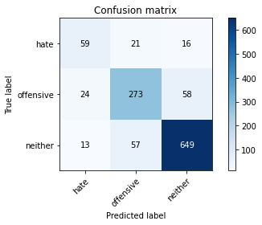

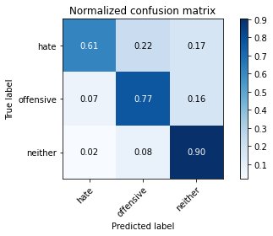

precision recall f1-score support

hate 0.61 0.61 0.61 96

offensive 0.78 0.77 0.77 355

neither 0.90 0.90 0.90 719

accuracy 0.84 1170

macro avg 0.76 0.76 0.76 1170

weighted avg 0.84 0.84 0.84 1170

average eval_loss: 0.8851473002632393, accuracy: 0.8384615384615385

training 19 epoch...

68.76396203041077 seconds used......

19 training finished! average train loss: 0.028682859783610837

total clf loss: 2.427148479720927 total adv loss: 2.1423203892650236

evaluating...

Confusion matrix, without normalization

[[ 59 24 13]

[ 22 272 61]

[ 20 60 639]]

Normalized confusion matrix

[[0.61458333 0.25 0.13541667]

[0.06197183 0.76619718 0.17183099]

[0.02781641 0.08344924 0.88873435]]

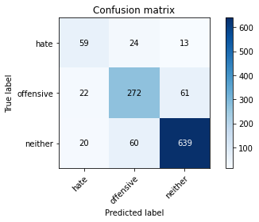

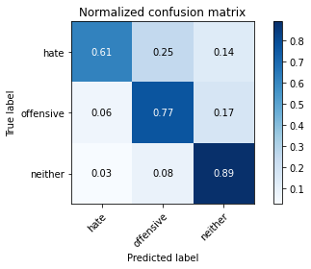

precision recall f1-score support

hate 0.58 0.61 0.60 96

offensive 0.76 0.77 0.77 355

neither 0.90 0.89 0.89 719

accuracy 0.83 1170

macro avg 0.75 0.76 0.75 1170

weighted avg 0.83 0.83 0.83 1170

average eval_loss: 0.9352696443556697, accuracy: 0.8290598290598291

training 20 epoch...

68.78317332267761 seconds used......

20 training finished! average train loss: 0.033533324159063155

total clf loss: 2.6108849112933967 total adv loss: 2.6179564778185522

evaluating...

Confusion matrix, without normalization

[[ 49 26 21]

[ 23 248 84]

[ 15 35 669]]

Normalized confusion matrix

[[0.51041667 0.27083333 0.21875 ]

[0.06478873 0.69859155 0.23661972]

[0.02086231 0.04867872 0.93045897]]

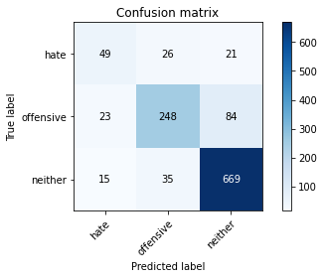

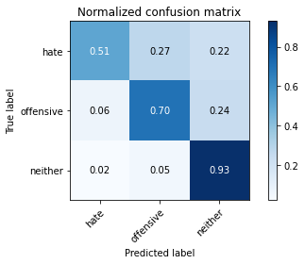

precision recall f1-score support

hate 0.56 0.51 0.54 96

offensive 0.80 0.70 0.75 355

neither 0.86 0.93 0.90 719

accuracy 0.83 1170

macro avg 0.74 0.71 0.73 1170

weighted avg 0.82 0.83 0.82 1170

average eval_loss: 0.9265139219864129, accuracy: 0.8256410256410256

5 run......

training 1 epoch...

68.7725419998169 seconds used......

1 training finished! average train loss: 1.4681631330496225

total clf loss: 141.03340934216976 total adv loss: 101.25838249921799

evaluating...

Confusion matrix, without normalization

[[ 15 58 23]

[ 3 287 65]

[ 0 77 642]]

Normalized confusion matrix

[[0.15625 0.60416667 0.23958333]

[0.0084507 0.8084507 0.18309859]

[0. 0.10709318 0.89290682]]

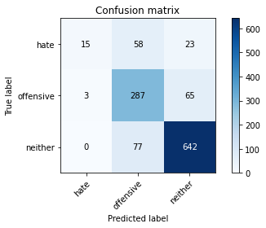

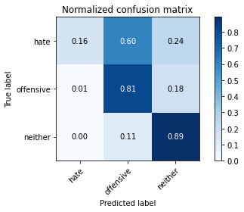

precision recall f1-score support

hate 0.83 0.16 0.26 96

offensive 0.68 0.81 0.74 355

neither 0.88 0.89 0.89 719

accuracy 0.81 1170

macro avg 0.80 0.62 0.63 1170

weighted avg 0.82 0.81 0.79 1170

average eval_loss: 0.47124336925098453, accuracy: 0.8068376068376069

training 2 epoch...

68.82744574546814 seconds used......

2 training finished! average train loss: 0.8115903907097303

total clf loss: 77.67587752267718 total adv loss: 56.118136851117015

evaluating...

Confusion matrix, without normalization

[[ 33 49 14]

[ 8 309 38]

[ 12 113 594]]

Normalized confusion matrix

[[0.34375 0.51041667 0.14583333]

[0.02253521 0.87042254 0.10704225]

[0.01668985 0.15716273 0.82614743]]

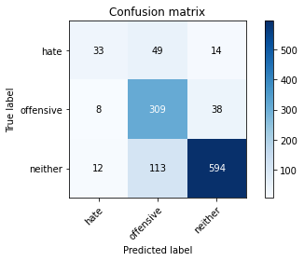

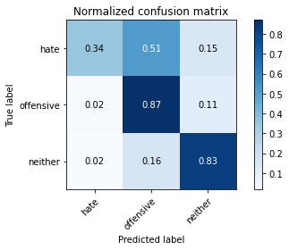

precision recall f1-score support

hate 0.62 0.34 0.44 96

offensive 0.66 0.87 0.75 355

neither 0.92 0.83 0.87 719

accuracy 0.80 1170

macro avg 0.73 0.68 0.69 1170

weighted avg 0.82 0.80 0.80 1170

average eval_loss: 0.5149716060545485, accuracy: 0.8

training 3 epoch...

68.75915503501892 seconds used......

3 training finished! average train loss: 0.38727493824548703

total clf loss: 38.768935290165246 total adv loss: 25.926700162468478

evaluating...

Confusion matrix, without normalization

[[ 46 38 12]

[ 24 288 43]

[ 23 86 610]]

Normalized confusion matrix

[[0.47916667 0.39583333 0.125 ]

[0.06760563 0.81126761 0.12112676]

[0.03198887 0.11961057 0.84840056]]

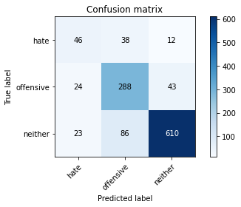

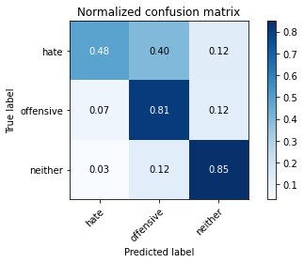

precision recall f1-score support

hate 0.49 0.48 0.49 96

offensive 0.70 0.81 0.75 355

neither 0.92 0.85 0.88 719

accuracy 0.81 1170

macro avg 0.70 0.71 0.71 1170

weighted avg 0.82 0.81 0.81 1170

average eval_loss: 0.5876279555387416, accuracy: 0.8068376068376069

training 4 epoch...

68.79483962059021 seconds used......

4 training finished! average train loss: 0.19819029365093088

total clf loss: 22.384004424791783 total adv loss: 11.99626202667423

evaluating...

Confusion matrix, without normalization

[[ 45 36 15]

[ 13 280 62]

[ 12 68 639]]

Normalized confusion matrix

[[0.46875 0.375 0.15625 ]

[0.03661972 0.78873239 0.17464789]

[0.01668985 0.0945758 0.88873435]]

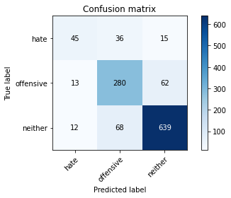

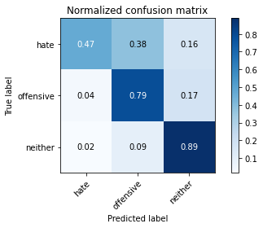

precision recall f1-score support

hate 0.64 0.47 0.54 96

offensive 0.73 0.79 0.76 355

neither 0.89 0.89 0.89 719

accuracy 0.82 1170

macro avg 0.75 0.72 0.73 1170

weighted avg 0.82 0.82 0.82 1170

average eval_loss: 0.6633523171609741, accuracy: 0.8239316239316239

training 5 epoch...

68.6916720867157 seconds used......

5 training finished! average train loss: 0.15016343298917398

total clf loss: 14.792285806848668 total adv loss: 10.172978639806388

evaluating...

Confusion matrix, without normalization

[[ 67 23 6]

[ 50 261 44]

[ 73 84 562]]

Normalized confusion matrix

[[0.69791667 0.23958333 0.0625 ]

[0.14084507 0.73521127 0.12394366]

[0.1015299 0.11682893 0.78164117]]

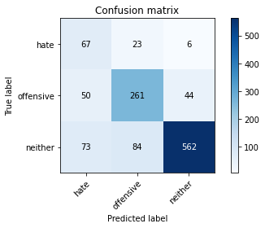

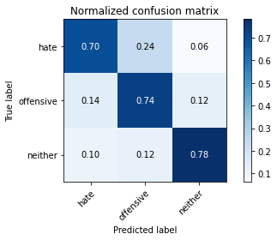

precision recall f1-score support

hate 0.35 0.70 0.47 96

offensive 0.71 0.74 0.72 355

neither 0.92 0.78 0.84 719

accuracy 0.76 1170

macro avg 0.66 0.74 0.68 1170

weighted avg 0.81 0.76 0.78 1170

average eval_loss: 0.7817510736443228, accuracy: 0.7606837606837606

training 6 epoch...

68.79029703140259 seconds used......

6 training finished! average train loss: 0.11766801444260387

total clf loss: 12.38393401086796 total adv loss: 7.575190796982497

evaluating...

Confusion matrix, without normalization

[[ 61 22 13]

[ 28 263 64]

[ 31 55 633]]

Normalized confusion matrix

[[0.63541667 0.22916667 0.13541667]

[0.07887324 0.74084507 0.18028169]

[0.04311544 0.07649513 0.88038943]]

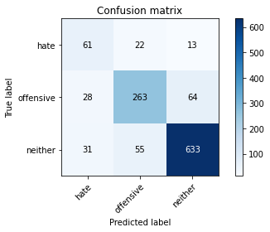

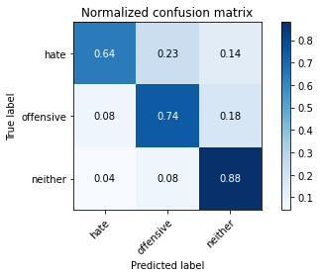

precision recall f1-score support

hate 0.51 0.64 0.56 96

offensive 0.77 0.74 0.76 355

neither 0.89 0.88 0.89 719

accuracy 0.82 1170

macro avg 0.72 0.75 0.74 1170

weighted avg 0.82 0.82 0.82 1170

average eval_loss: 0.7400933827068341, accuracy: 0.8179487179487179

training 7 epoch...

68.74713802337646 seconds used......

7 training finished! average train loss: 0.0443478041426995

total clf loss: 4.1827144823619165 total adv loss: 3.0973358398514392

evaluating...

Confusion matrix, without normalization

[[ 49 30 17]

[ 22 249 84]

[ 19 32 668]]

Normalized confusion matrix

[[0.51041667 0.3125 0.17708333]

[0.06197183 0.70140845 0.23661972]

[0.02642559 0.04450626 0.92906815]]

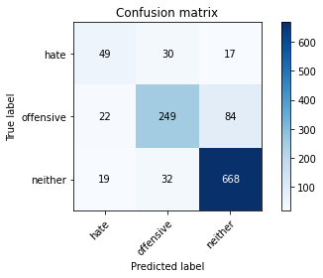

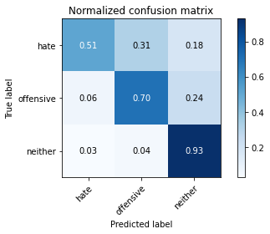

precision recall f1-score support

hate 0.54 0.51 0.53 96

offensive 0.80 0.70 0.75 355

neither 0.87 0.93 0.90 719

accuracy 0.83 1170

macro avg 0.74 0.71 0.72 1170

weighted avg 0.82 0.83 0.82 1170

average eval_loss: 0.870416886512569, accuracy: 0.8256410256410256

training 8 epoch...

68.80921721458435 seconds used......

8 training finished! average train loss: 0.06474752435371137

total clf loss: 6.44350921313162 total adv loss: 4.353705739484212

evaluating...

Confusion matrix, without normalization

[[ 47 37 12]

[ 19 275 61]

[ 15 64 640]]

Normalized confusion matrix

[[0.48958333 0.38541667 0.125 ]

[0.05352113 0.77464789 0.17183099]

[0.02086231 0.08901252 0.89012517]]

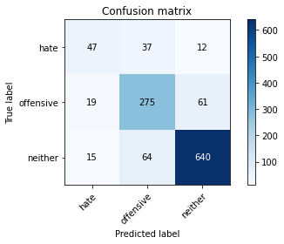

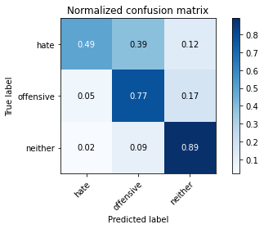

precision recall f1-score support

hate 0.58 0.49 0.53 96

offensive 0.73 0.77 0.75 355

neither 0.90 0.89 0.89 719

accuracy 0.82 1170

macro avg 0.74 0.72 0.73 1170

weighted avg 0.82 0.82 0.82 1170

average eval_loss: 0.8103303053432097, accuracy: 0.8222222222222222

training 9 epoch...

68.77789187431335 seconds used......

9 training finished! average train loss: 0.07618252080059253

total clf loss: 6.30031998155755 total adv loss: 5.763194841390941

evaluating...

Confusion matrix, without normalization

[[ 38 48 10]

[ 10 302 43]

[ 9 123 587]]

Normalized confusion matrix

[[0.39583333 0.5 0.10416667]

[0.02816901 0.85070423 0.12112676]

[0.01251739 0.17107093 0.81641168]]

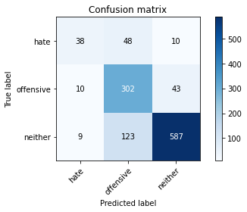

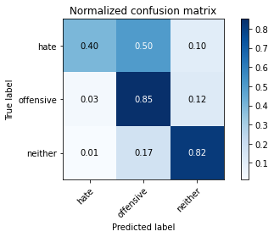

precision recall f1-score support

hate 0.67 0.40 0.50 96

offensive 0.64 0.85 0.73 355

neither 0.92 0.82 0.86 719

accuracy 0.79 1170

macro avg 0.74 0.69 0.70 1170

weighted avg 0.81 0.79 0.79 1170

average eval_loss: 0.9164919709250078, accuracy: 0.7923076923076923

training 10 epoch...

68.80397510528564 seconds used......

10 training finished! average train loss: 0.0793719583710369

total clf loss: 7.179550096188905 total adv loss: 5.696744043925719

evaluating...

Confusion matrix, without normalization

[[ 45 40 11]

[ 13 288 54]

[ 10 89 620]]

Normalized confusion matrix

[[0.46875 0.41666667 0.11458333]

[0.03661972 0.81126761 0.15211268]

[0.01390821 0.12378303 0.86230876]]

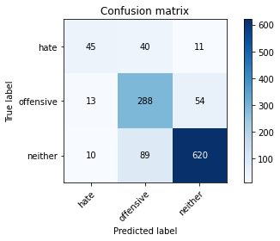

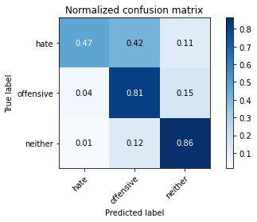

precision recall f1-score support

hate 0.66 0.47 0.55 96

offensive 0.69 0.81 0.75 355

neither 0.91 0.86 0.88 719

accuracy 0.81 1170

macro avg 0.75 0.71 0.73 1170

weighted avg 0.82 0.81 0.81 1170

average eval_loss: 0.824565524014376, accuracy: 0.8145299145299145

training 11 epoch...

68.73843336105347 seconds used......

11 training finished! average train loss: 0.05465382075150652

total clf loss: 4.832620067434618 total adv loss: 3.978186993756026

evaluating...

Confusion matrix, without normalization

[[ 52 30 14]

[ 24 282 49]

[ 24 95 600]]

Normalized confusion matrix

[[0.54166667 0.3125 0.14583333]

[0.06760563 0.7943662 0.13802817]

[0.03337969 0.13212796 0.83449235]]

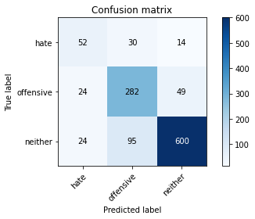

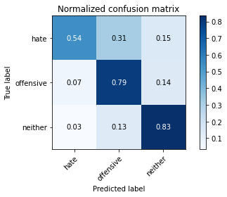

precision recall f1-score support

hate 0.52 0.54 0.53 96

offensive 0.69 0.79 0.74 355

neither 0.90 0.83 0.87 719

accuracy 0.80 1170

macro avg 0.71 0.72 0.71 1170

weighted avg 0.81 0.80 0.80 1170

average eval_loss: 0.9074757885408856, accuracy: 0.7982905982905983

training 12 epoch...

68.77613806724548 seconds used......

12 training finished! average train loss: 0.09565794085036529

total clf loss: 9.28214078003657 total adv loss: 6.550908629774767

evaluating...

Confusion matrix, without normalization

[[ 65 17 14]

[ 44 250 61]

[ 23 55 641]]

Normalized confusion matrix

[[0.67708333 0.17708333 0.14583333]

[0.12394366 0.70422535 0.17183099]

[0.03198887 0.07649513 0.89151599]]

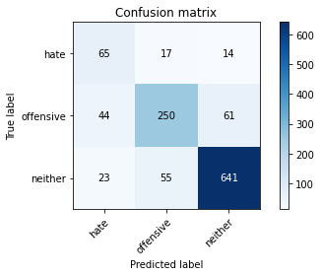

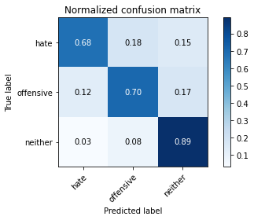

precision recall f1-score support

hate 0.49 0.68 0.57 96

offensive 0.78 0.70 0.74 355

neither 0.90 0.89 0.89 719

accuracy 0.82 1170

macro avg 0.72 0.76 0.73 1170

weighted avg 0.83 0.82 0.82 1170

average eval_loss: 0.9061619036720466, accuracy: 0.8170940170940171

training 13 epoch...

68.87587523460388 seconds used......

13 training finished! average train loss: 0.05608672314048864

total clf loss: 5.186964981752681 total adv loss: 3.968664156496743

evaluating...

Confusion matrix, without normalization

[[ 58 27 11]

[ 35 257 63]

[ 30 54 635]]

Normalized confusion matrix

[[0.60416667 0.28125 0.11458333]

[0.09859155 0.72394366 0.17746479]

[0.04172462 0.07510431 0.88317107]]

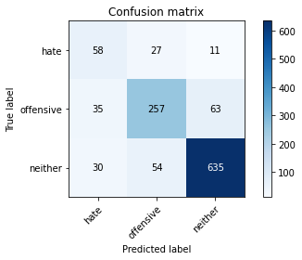

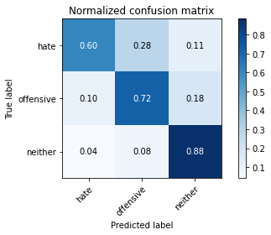

precision recall f1-score support

hate 0.47 0.60 0.53 96

offensive 0.76 0.72 0.74 355

neither 0.90 0.88 0.89 719

accuracy 0.81 1170

macro avg 0.71 0.74 0.72 1170

weighted avg 0.82 0.81 0.82 1170

average eval_loss: 0.8865339945788668, accuracy: 0.811965811965812

training 14 epoch...

68.74431419372559 seconds used......

14 training finished! average train loss: 0.02412097929650022

total clf loss: 2.2990093539265217 total adv loss: 1.6726498861362415

evaluating...

Confusion matrix, without normalization

[[ 57 22 17]

[ 38 255 62]

[ 34 49 636]]

Normalized confusion matrix

[[0.59375 0.22916667 0.17708333]

[0.10704225 0.71830986 0.17464789]

[0.0472879 0.06815021 0.88456189]]

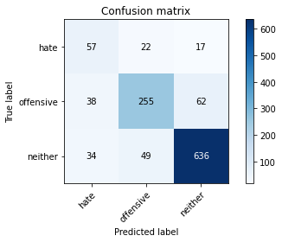

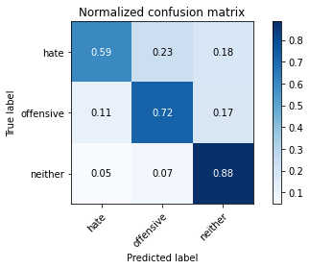

precision recall f1-score support

hate 0.44 0.59 0.51 96

offensive 0.78 0.72 0.75 355

neither 0.89 0.88 0.89 719

accuracy 0.81 1170

macro avg 0.70 0.73 0.71 1170

weighted avg 0.82 0.81 0.81 1170

average eval_loss: 1.021593145641372, accuracy: 0.8102564102564103

training 15 epoch...

69.05207467079163 seconds used......

15 training finished! average train loss: 0.033448893198324066

total clf loss: 3.2904761195895844 total adv loss: 2.268282499498582

evaluating...

Confusion matrix, without normalization

[[ 60 17 19]

[ 33 258 64]

[ 21 51 647]]

Normalized confusion matrix

[[0.625 0.17708333 0.19791667]

[0.09295775 0.72676056 0.18028169]

[0.02920723 0.07093185 0.89986092]]

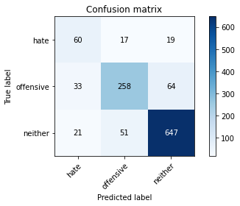

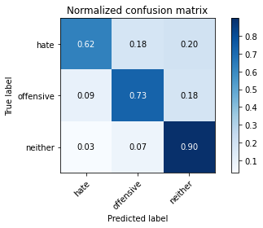

precision recall f1-score support

hate 0.53 0.62 0.57 96

offensive 0.79 0.73 0.76 355

neither 0.89 0.90 0.89 719

accuracy 0.82 1170

macro avg 0.73 0.75 0.74 1170

weighted avg 0.83 0.82 0.83 1170

average eval_loss: 0.9619636453778909, accuracy: 0.8247863247863247

training 16 epoch...

69.13921022415161 seconds used......

16 training finished! average train loss: 0.04220433665887735

total clf loss: 3.5357867535349214 total adv loss: 3.1700139662716538

evaluating...

Confusion matrix, without normalization

[[ 48 24 24]

[ 20 256 79]

[ 9 48 662]]

Normalized confusion matrix

[[0.5 0.25 0.25 ]

[0.05633803 0.72112676 0.22253521]

[0.01251739 0.06675939 0.92072323]]

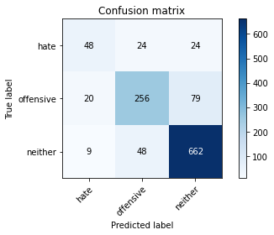

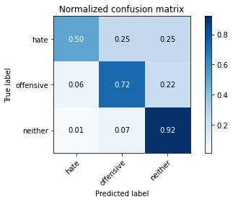

precision recall f1-score support

hate 0.62 0.50 0.55 96

offensive 0.78 0.72 0.75 355

neither 0.87 0.92 0.89 719

accuracy 0.83 1170

macro avg 0.76 0.71 0.73 1170

weighted avg 0.82 0.83 0.82 1170

average eval_loss: 0.9949061621379569, accuracy: 0.8256410256410256

training 17 epoch...

69.07954716682434 seconds used......

17 training finished! average train loss: 0.0636625339101222

total clf loss: 5.5835465365234995 total adv loss: 4.656743172077768

evaluating...

Confusion matrix, without normalization

[[ 55 19 22]

[ 27 248 80]

[ 19 46 654]]

Normalized confusion matrix

[[0.57291667 0.19791667 0.22916667]

[0.07605634 0.69859155 0.22535211]

[0.02642559 0.06397775 0.90959666]]

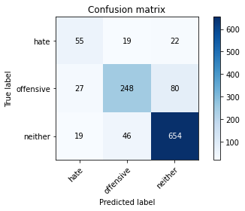

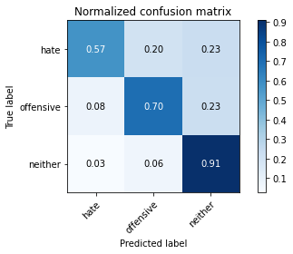

precision recall f1-score support

hate 0.54 0.57 0.56 96

offensive 0.79 0.70 0.74 355

neither 0.87 0.91 0.89 719

accuracy 0.82 1170

macro avg 0.73 0.73 0.73 1170

weighted avg 0.82 0.82 0.82 1170

average eval_loss: 0.9313725772766609, accuracy: 0.8179487179487179

training 18 epoch...

69.04691743850708 seconds used......

18 training finished! average train loss: 0.04425883243264905

total clf loss: 3.8650623892390286 total adv loss: 3.245752202916492

evaluating...

Confusion matrix, without normalization

[[ 52 30 14]

[ 18 289 48]

[ 20 79 620]]

Normalized confusion matrix

[[0.54166667 0.3125 0.14583333]

[0.05070423 0.81408451 0.13521127]

[0.02781641 0.10987483 0.86230876]]

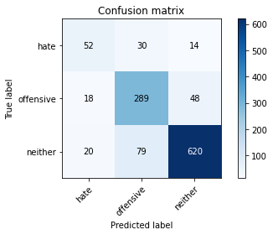

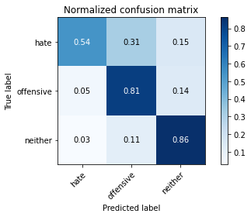

precision recall f1-score support

hate 0.58 0.54 0.56 96

offensive 0.73 0.81 0.77 355

neither 0.91 0.86 0.89 719

accuracy 0.82 1170

macro avg 0.74 0.74 0.74 1170

weighted avg 0.83 0.82 0.82 1170

average eval_loss: 0.9560934974460752, accuracy: 0.8213675213675213

training 19 epoch...

69.13363814353943 seconds used......

19 training finished! average train loss: 0.020961130259012053

total clf loss: 1.9966888471899438 total adv loss: 1.4541078290980067

evaluating...

Confusion matrix, without normalization

[[ 34 44 18]

[ 9 299 47]

[ 8 87 624]]

Normalized confusion matrix

[[0.35416667 0.45833333 0.1875 ]

[0.02535211 0.84225352 0.13239437]

[0.01112656 0.12100139 0.86787204]]

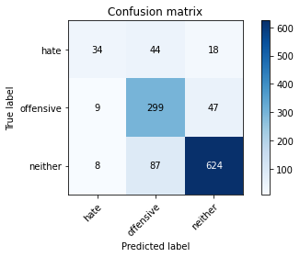

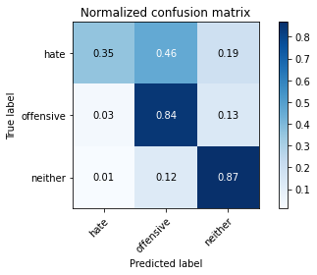

precision recall f1-score support

hate 0.67 0.35 0.46 96

offensive 0.70 0.84 0.76 355

neither 0.91 0.87 0.89 719

accuracy 0.82 1170

macro avg 0.76 0.69 0.70 1170

weighted avg 0.82 0.82 0.81 1170

average eval_loss: 1.092881236580532, accuracy: 0.8179487179487179

training 20 epoch...

69.1190025806427 seconds used......

20 training finished! average train loss: 0.02593268905016325

total clf loss: 2.1187463434616802 total adv loss: 1.974751459486356

evaluating...

Confusion matrix, without normalization

[[ 50 33 13]

[ 20 278 57]

[ 28 72 619]]

Normalized confusion matrix

[[0.52083333 0.34375 0.13541667]

[0.05633803 0.78309859 0.16056338]

[0.03894298 0.10013908 0.86091794]]

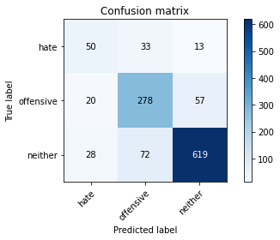

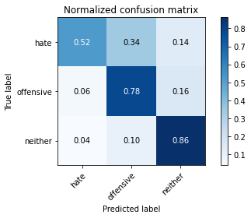

precision recall f1-score support

hate 0.51 0.52 0.52 96

offensive 0.73 0.78 0.75 355

neither 0.90 0.86 0.88 719

accuracy 0.81 1170

macro avg 0.71 0.72 0.72 1170

weighted avg 0.81 0.81 0.81 1170

average eval_loss: 0.9987679669412516, accuracy: 0.8094017094017094